| Cybersecurity |
| --- |
| Penetration Test Report |

Rekall Corporation

Penetration Test Report

**Student Note: Complete all sections highlighted in yellow.**

# 

## Confidentiality Statement

This document contains confidential and privileged information from Rekall Inc. (henceforth known as Rekall). The information contained in this document is confidential and may constitute inside or non-public information under international, federal, or state laws. Unauthorized forwarding, printing, copying, distribution, or use of such information is strictly prohibited and may be unlawful. If you are not the intended recipient, be aware that any disclosure, copying, or distribution of this document or its parts is prohibited.

Table of Contents

Confidentiality Statement 2

Contact Information 4

Document History 4

Introduction 5

Assessment Objective 5

Penetration Testing Methodology 6

Reconnaissance 6

Identification of Vulnerabilities and Services 6

Vulnerability Exploitation 6

Reporting 6

Scope 7

Executive Summary of Findings 8

Grading Methodology 8

Summary of Strengths 9

Summary of Weaknesses 9

Executive Summary Narrative 10

Summary Vulnerability Overview 13

Vulnerability Findings 14

# 

## Contact Information

| **Company Name** | LinkStart, LLC |
| --- | --- |
| **Contact Name** | Cameron Wallace |
| **Contact Title** | Penetration Tester |

## 

## Document History

| **Version** | **Date** | **Author(s)** | **Comments** |
| --- | --- | --- | --- |
| 001 | 2/10/23 | Cameron Wallace |  |

# 

## Introduction

In accordance with Rekall policies, our organization conducts external and internal penetration tests of its networks and systems throughout the year. The purpose of this engagement was to assess the networks’ and systems’ security and identify potential security flaws by utilizing industry-accepted testing methodology and best practices.

For the testing, we focused on the following:

* Attempting to determine what system-level vulnerabilities could be discovered and exploited with no prior knowledge of the environment or notification to administrators.
* Attempting to exploit vulnerabilities found and access confidential information that may be stored on systems.
* Documenting and reporting on all findings.

All tests took into consideration the actual business processes implemented by the systems and their potential threats; therefore, the results of this assessment reflect a realistic picture of the actual exposure levels to online hackers. This document contains the results of that assessment.

### Assessment Objective

The primary goal of this assessment was to provide an analysis of security flaws present in Rekall’s web applications, networks, and systems. This assessment was conducted to identify exploitable vulnerabilities and provide actionable recommendations on how to remediate the vulnerabilities to provide a greater level of security for the environment.

We used our proven vulnerability testing methodology to assess all relevant web applications, networks, and systems in scope.

Rekall has outlined the following objectives:

Table 1: Defined Objectives

| **Objective** |
| --- |
| Find and exfiltrate any sensitive information within the domain. |
| Escalate privileges. |
| Compromise several machines. |

# 

## Penetration Testing Methodology

### Reconnaissance

### 

We begin assessments by checking for any passive (open source) data that may assist the assessors with their tasks. If internal, the assessment team will perform active recon using tools such as Nmap and Bloodhound.

### Identification of Vulnerabilities and Services

We use custom, private, and public tools such as Metasploit, hashcat, and Nmap to gain perspective of the network security from a hacker’s point of view. These methods provide Rekall with an understanding of the risks that threaten its information, and also the strengths and weaknesses of the current controls protecting those systems. The results were achieved by mapping the network architecture, identifying hosts and services, enumerating network and system-level vulnerabilities, attempting to discover unexpected hosts within the environment, and eliminating false positives that might have arisen from scanning.

### Vulnerability Exploitation

Our normal process is to both manually test each identified vulnerability and use automated tools to exploit these issues. Exploitation of a vulnerability is defined as any action we perform that gives us unauthorized access to the system or the sensitive data.

### Reporting

Once exploitation is completed and the assessors have completed their objectives, or have done everything possible within the allotted time, the assessment team writes the report, which is the final deliverable to the customer.

# 

## Scope

Prior to any assessment activities, Rekall and the assessment team will identify targeted systems with a defined range or list of network IP addresses. The assessment team will work directly with the Rekall POC to determine which network ranges are in-scope for the scheduled assessment.

It is Rekall’s responsibility to ensure that IP addresses identified as in-scope are actually controlled by Rekall and are hosted in Rekall-owned facilities (i.e., are not hosted by an external organization). In-scope and excluded IP addresses and ranges are listed below.

# 

# 

## Executive Summary of Findings

## 

### Grading Methodology

Each finding was classified according to its severity, reflecting the risk each such vulnerability may pose to the business processes implemented by the application, based on the following criteria:

**Critical**: Immediate threat to key business processes.

**High**: Indirect threat to key business processes/threat to secondary business processes.

**Medium**: Indirect or partial threat to business processes.

**Low**: No direct threat exists; vulnerability may be leveraged with other vulnerabilities.

Informational: No threat; however, it is data that may be used in a future attack.

As the following grid shows, each threat is assessed in terms of both its potential impact on the business and the likelihood of exploitation:

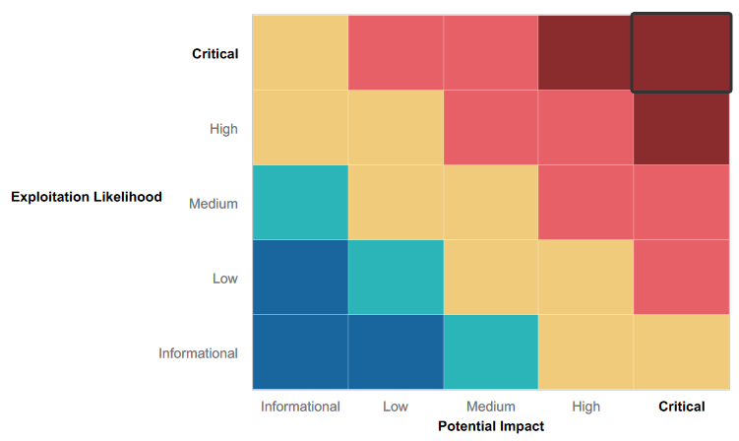

### 

### Summary of Strengths

While the assessment team was successful in finding several vulnerabilities, the team also recognized several strengths within Rekall’s environment. These positives highlight the effective countermeasures and defenses that successfully prevented, detected, or denied an attack technique or tactic from occurring.

* On the web application, there were some efforts made to prevent cross-site scripting and command injection via input validation.
* Within the web application, directory traversal is possible but file permissions are still maintained.

### Summary of Weaknesses

We successfully found several critical vulnerabilities that should be immediately addressed in order to prevent an adversary from compromising the network. These findings are not specific to a software version but are more general and systemic vulnerabilities.

* Exposed credentials both on Github repositories and the HTML of publicly available web-pages.
* Weak password requirements and policies.
* Able to traverse directories in web-pages via URL manipulation.
* Weak input validation that does very little to prevent injections.
* WAF (Web Application Firewall) not in place, allowing simple requests and scans access to too much information.
* Numerous open ports exposing servers to critical vulnerabilities.

## Executive Summary

The penetration assessment was conducted in the form of a targeted attack against the Rekall Corporation’s web application server, a dedicated linux server, and two separate windows servers in the form of a “Capture the Flag (CTF)” event designed to test and expose vulnerabilities.

The assessment began with a focus on Rekall Corporation’s web application server.

The first flag was accessed by inputting a reflected XSS payload into the name-entry field on the Welcome.php page (Figure 1). The inputted script was executed successfully, generating a pop-up not intended by the web page, thereby presenting the flag.

Payload used: <script>alert(“Hello”)</script>

Figure 1:

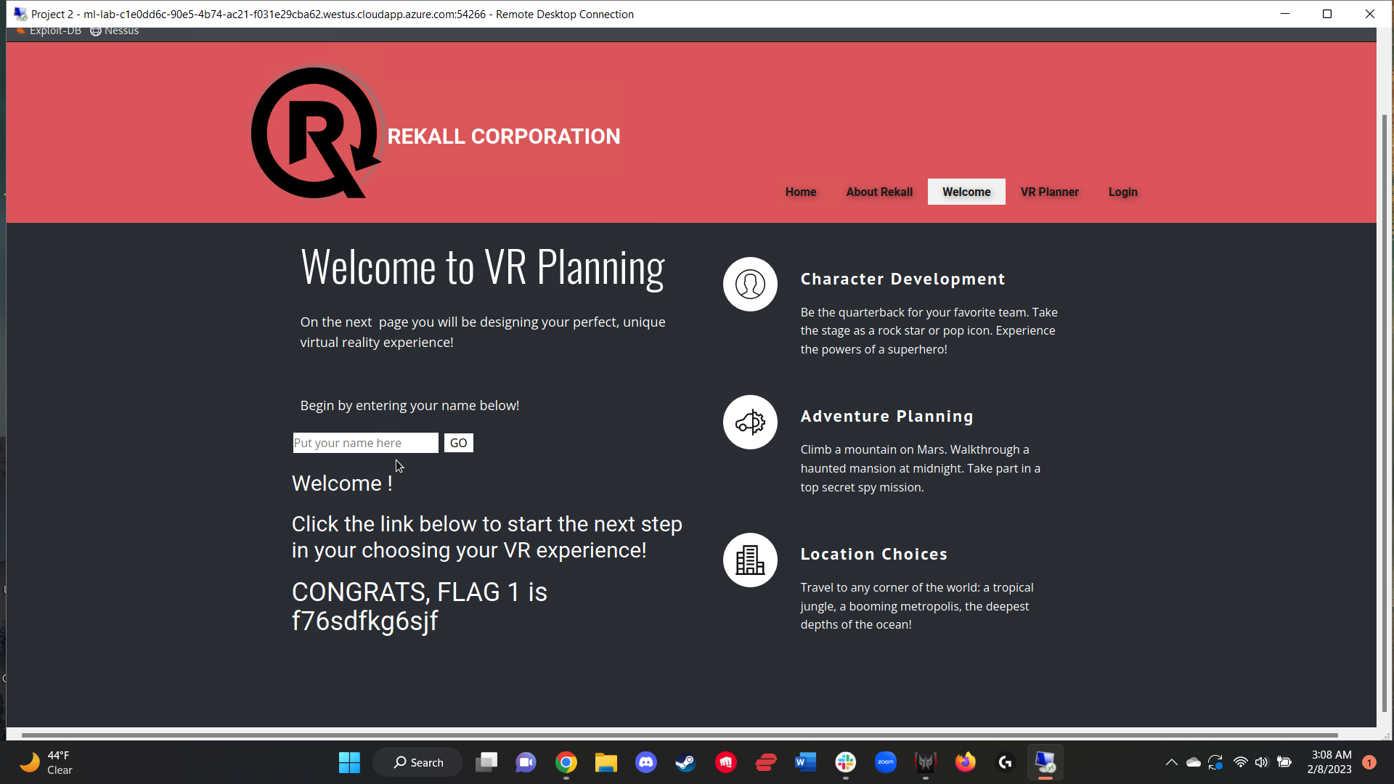

Flag 2 was similar to flag 1, in that it was accessible by inputting a XSS payload within a specific entry field, but it was more complicated due to input validation that rejected certain keywords/phrases. On the Memory-Planner.php web page, a script payload was inputted into the “Choose Your Character” field, with said script dodging input validation with simple character-placement manipulation, allowing the flag to be accessed (Figure 2).

Payload used: <scrscriptipt>alert(“Hello”)</scrscriptipt>

Figure 2:

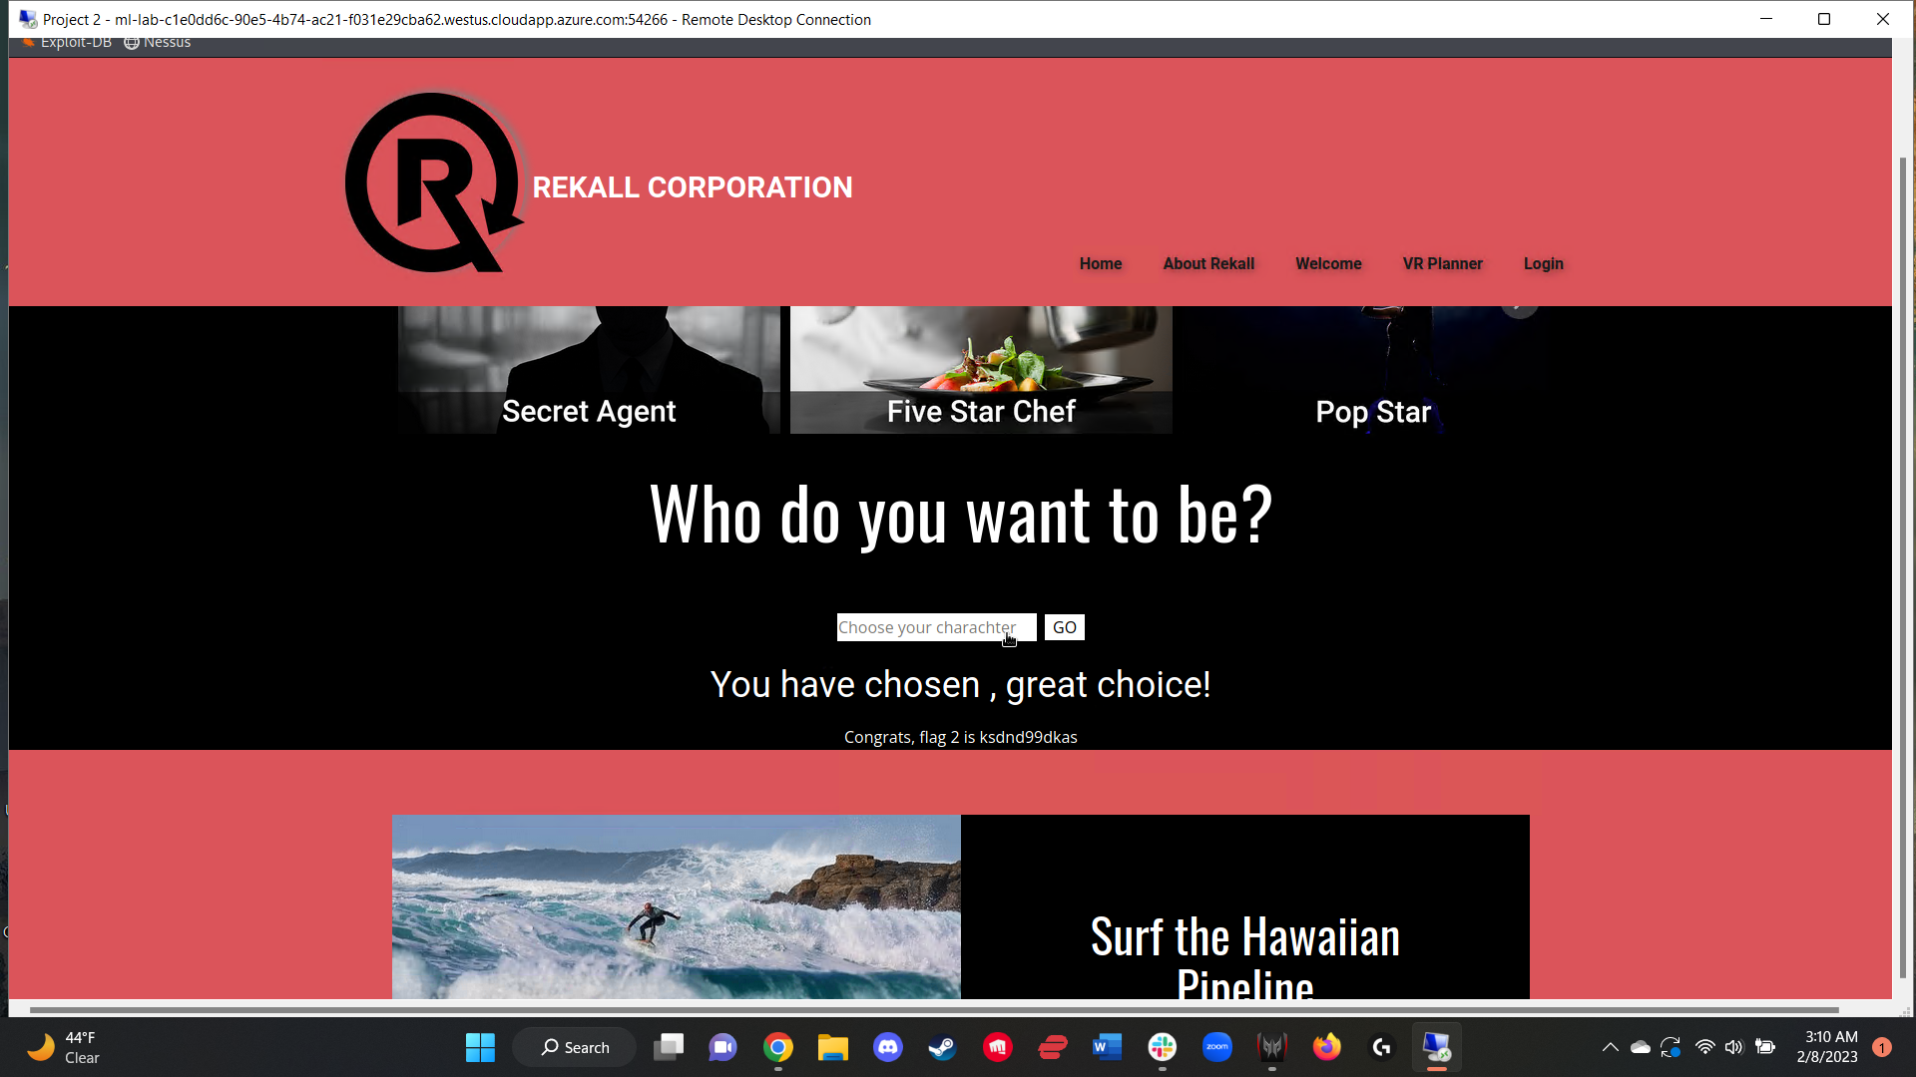

Just like flags 1 and 2, flag 3 was also accessed by inputting a XSS payload into a specific entry field. On the Comments.php webpage, the flag was generated after a simple script payload was inputted into the comments entry field (Figure 3).

Payload used: <script>alert(“Hello”)</script>

Figure 3:

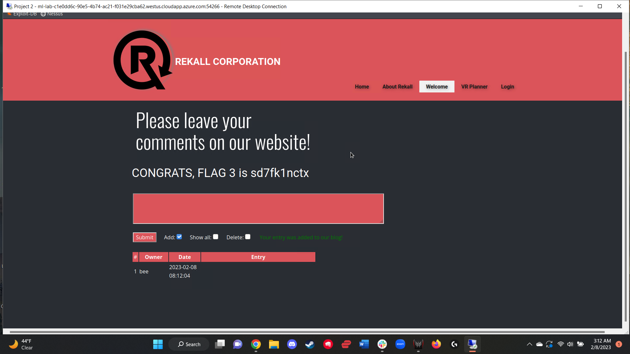

The next flag was accessed by running a *curl* command on the About-Rekall.php web page that took advantage of an open port 80. The command returned an output that included the HTTP response headers that revealed flag 4 (Figure 4).

Command used: curl -v 192.168.14.35/About-Rekall.php

Figure 4:

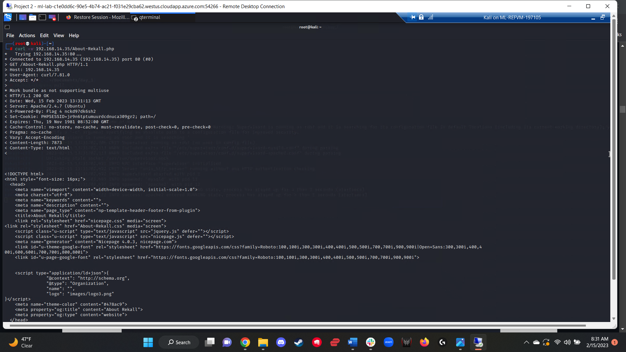

Both flags 5 and 6 were accessed by exploiting the same vulnerability, specifically that of Local File Inclusion (LFI). This was accomplished by using the file upload feature on the Memory-Planner.php webpage. To generate flag 5, the file simply had to be uploaded into the second field with a .php extension (figure 5). To generate flag 6, the same methodology was used, but input validation that denied all files that did not end with a .jpg extension required the use of a different file. To circumvent this, I created and uploaded a file with a .php.jpg extension into the third field (figure 6).

Figure 5:

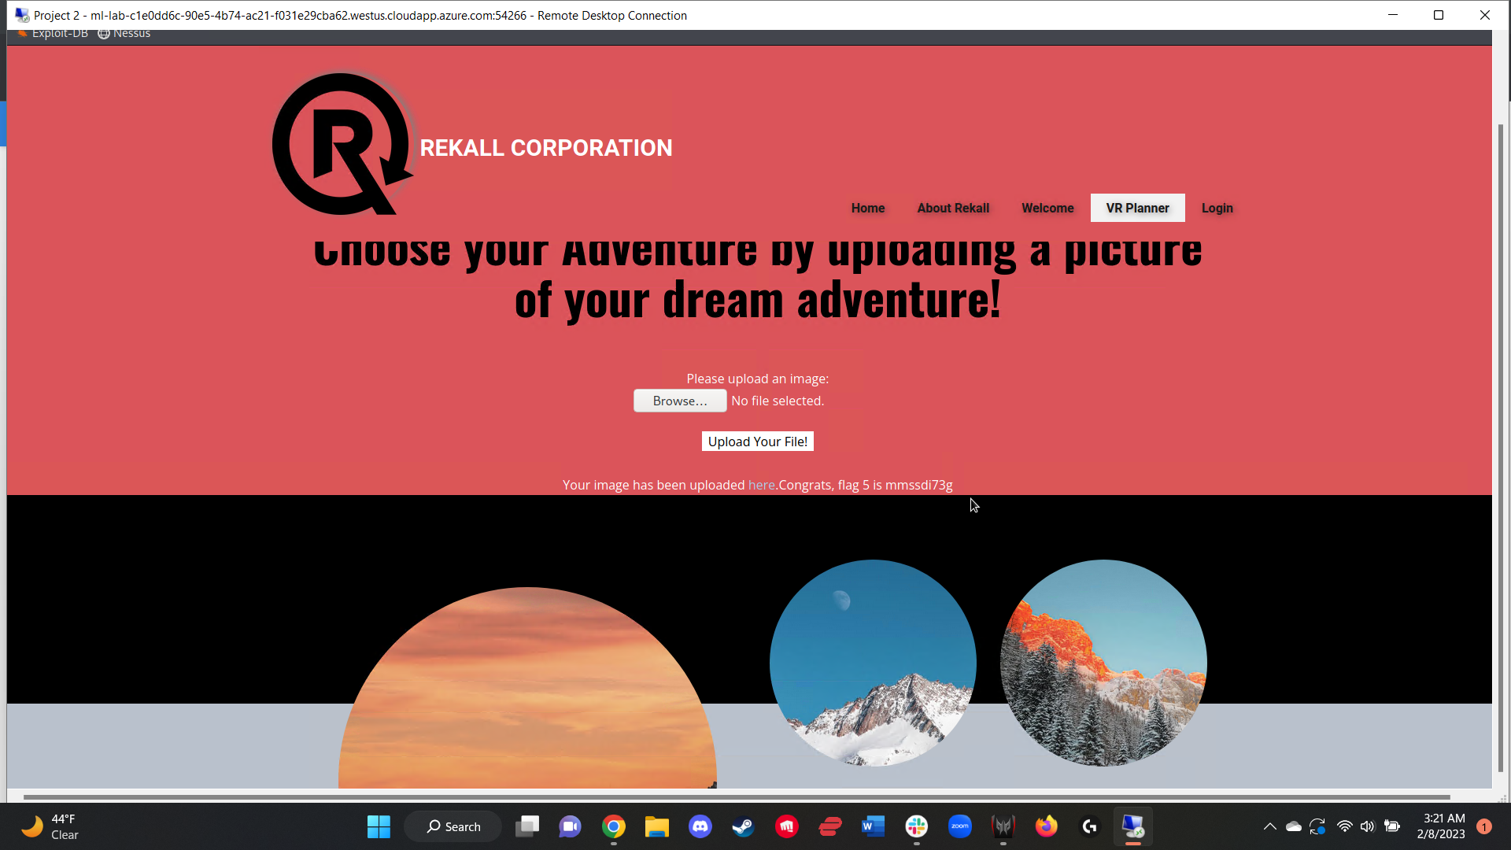

Figure 6:

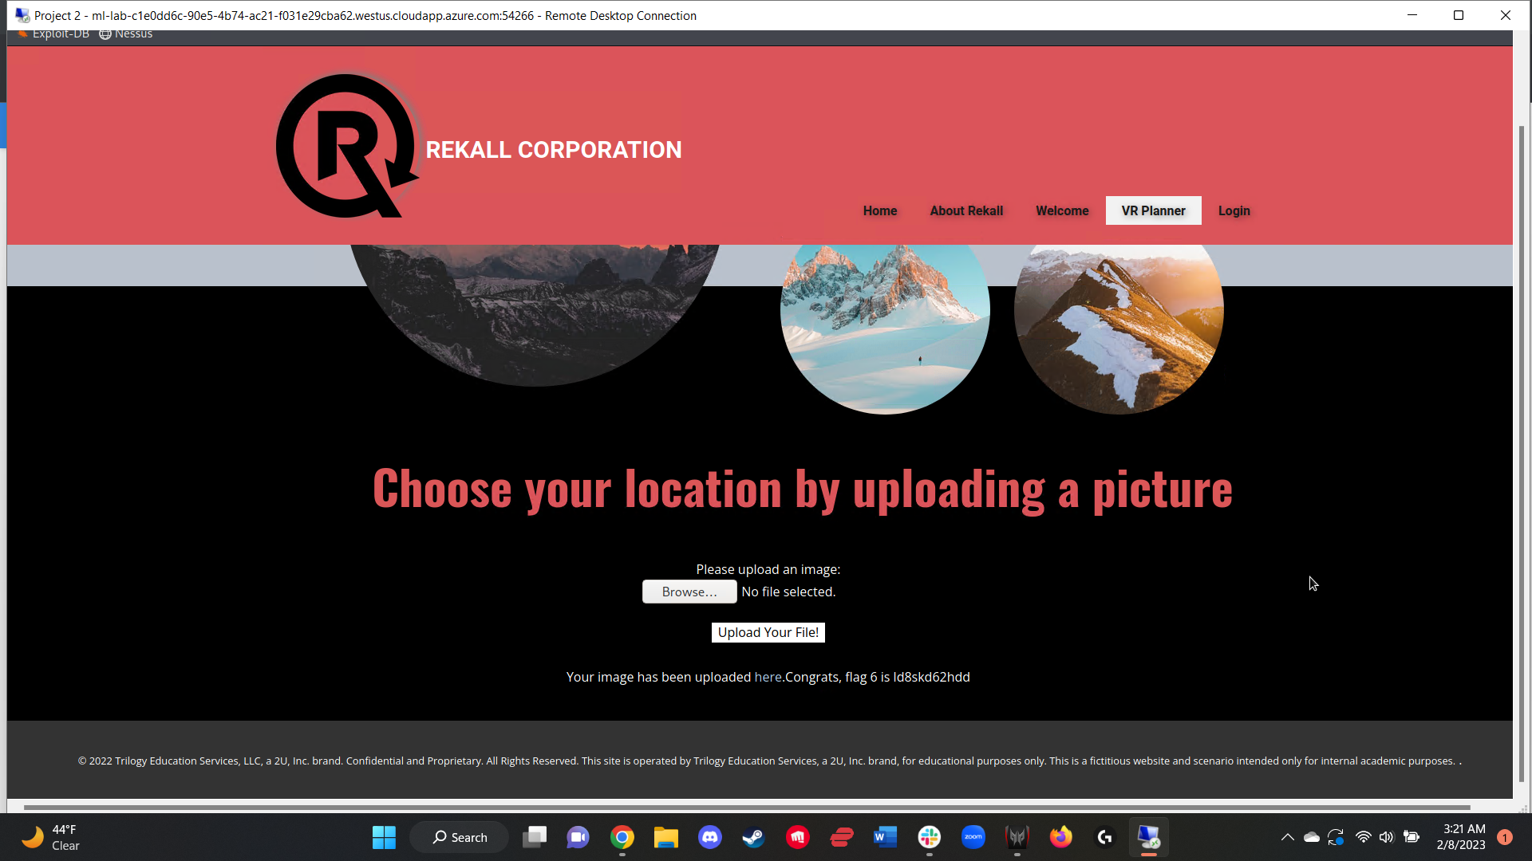

In order to access flag 7, I accessed the Login.php page and inputted a single ‘ into the first password field to test if it prompted a mysql error. After the error was confirmed, injected a SQL payload into the password field to successfully login, thus generating the flag (figure 7).

Payload used: ‘ OR ‘1’ = ‘1

Figure 7:

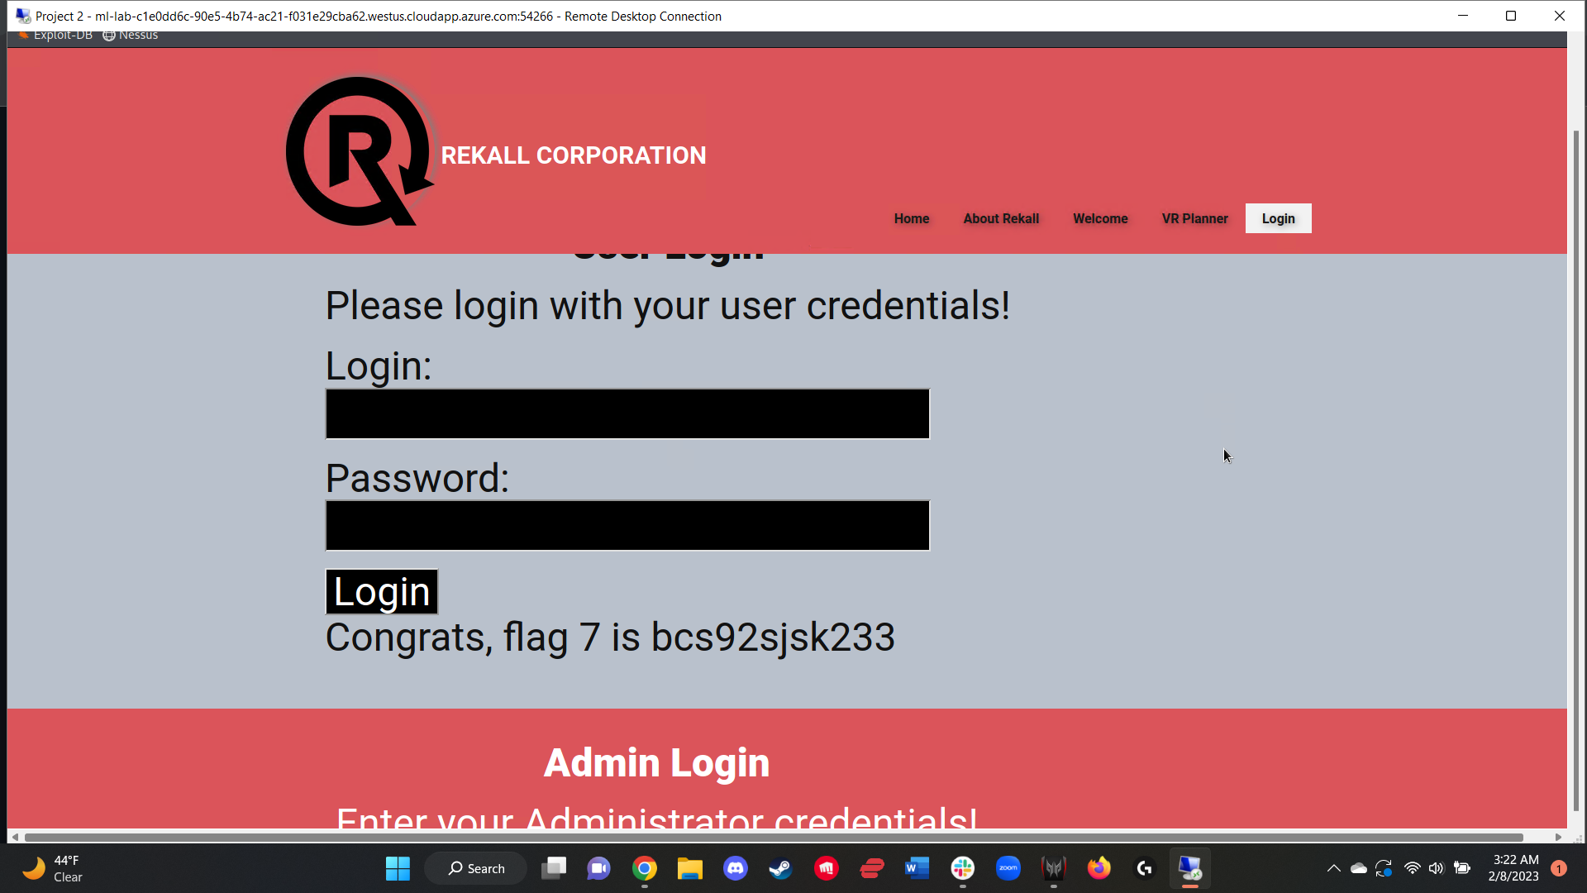

Flag 8 was found by logging in using administrator credentials (figure 8). These administrator credentials were found by accessing the HTML page source of the Login.php webpage, alternatively, could be found by highlighting the space above the second login field also on the login.php web page.

Figure 8:

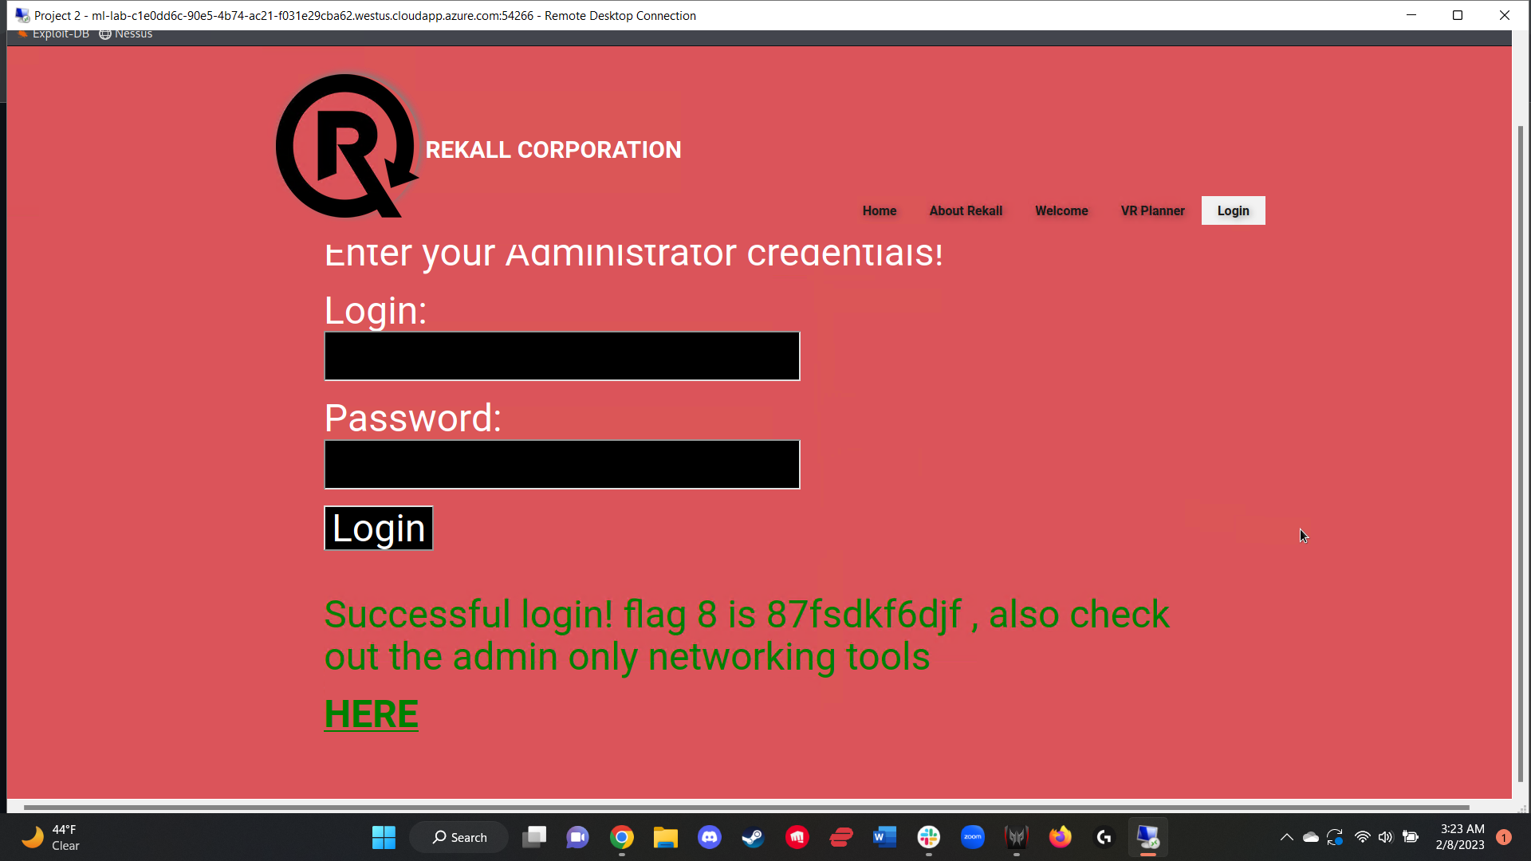

The robots.txt file was accessible via simple URL manipulation, and loading the web page 192.168.14.35/robots.txt, revealing flag 9 (figure 9).

Figure 9:

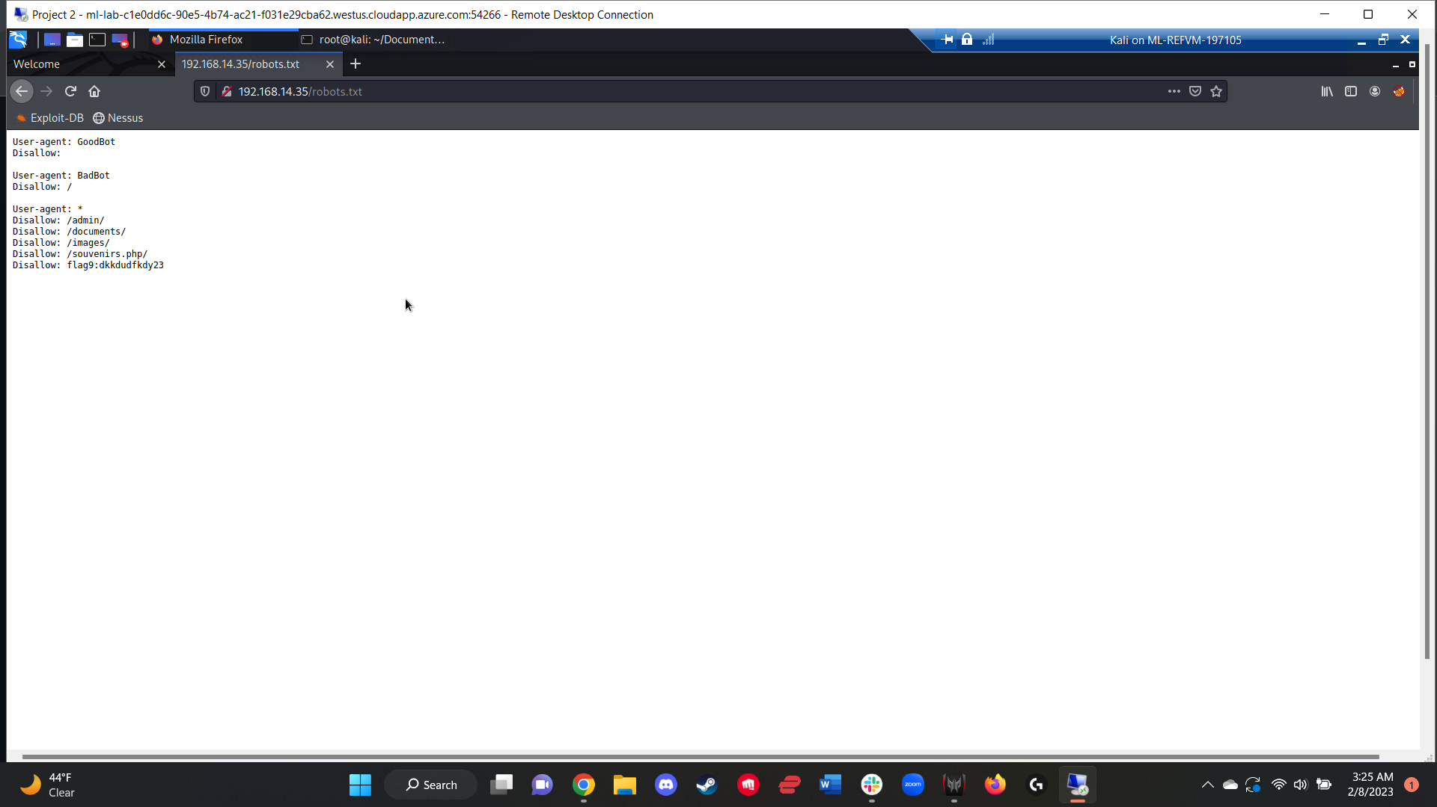

The admin only networking tools page (Networking.php) accessible after inputting the admin credentials presented two data fields, one for a DNS check, the other a MX record checker. Flags 10 and 11 were both able to be found via command injection into these two fields. Flag 10 involved inserting a command injection payload into the DNS check field, generating the flag (figure 10). Flag 11 was found by inserting a command injection payload into the MX record checker field, though this one had input validation that needed to be circumvented. A successful input generated flag 11 (figure 11).

Payload used for flag 10: [www.example.com](http://www.example.com); cat vendors.txt

Payload used for flag 11: [www.example.com](http://www.example.com) | cat vendors.txt

Figure 10:

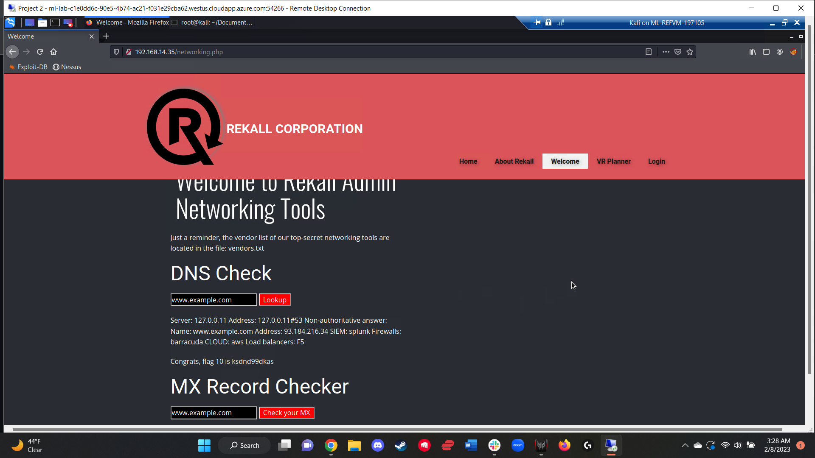

Figure 11:

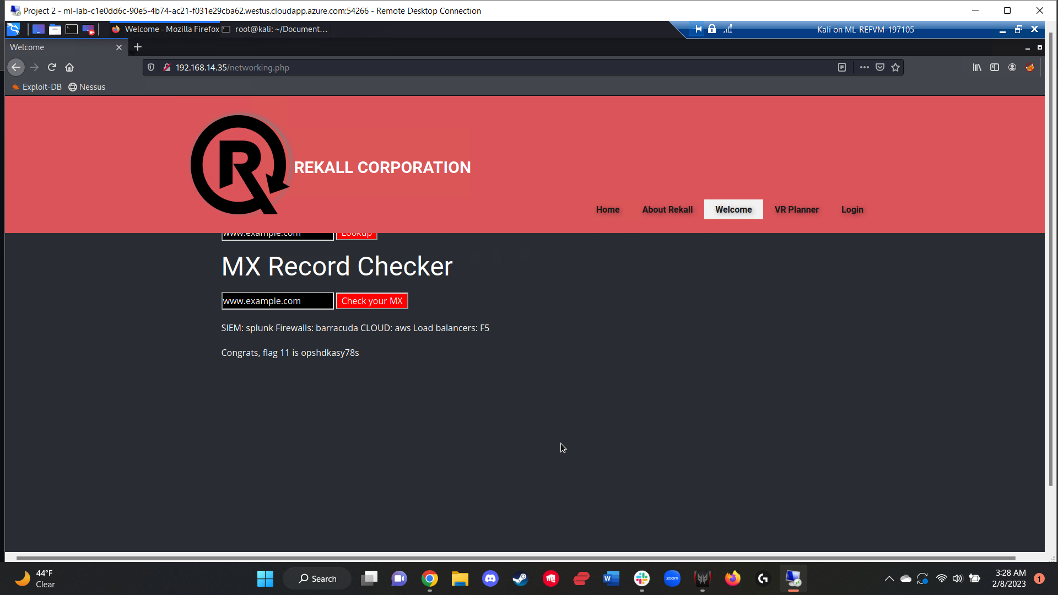

Following confirmation that directory traversal was possible via command injection and URL manipulation, took advantage of this on the Disclaimer.php?page=disclaimer_2.txt web page and manipulated the URL to access the /etc/passwd file. From the passwd file, I was able to view a list of system usernames (figure 12). From this, I found the user “melina” and was able to guess the associated password, which was also “melina.” Using melina:melina and inputting the name into the first login and password field on the Login.php web page revealed flag 12 (figure 13).

Figure 12:

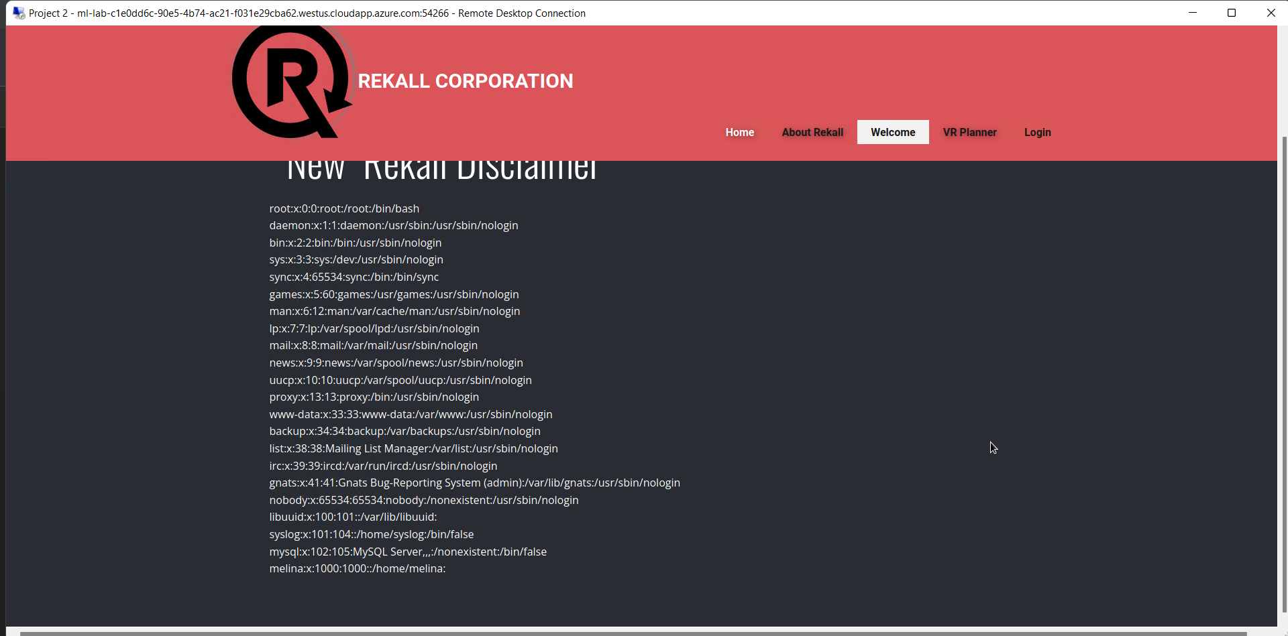

Figure 13:

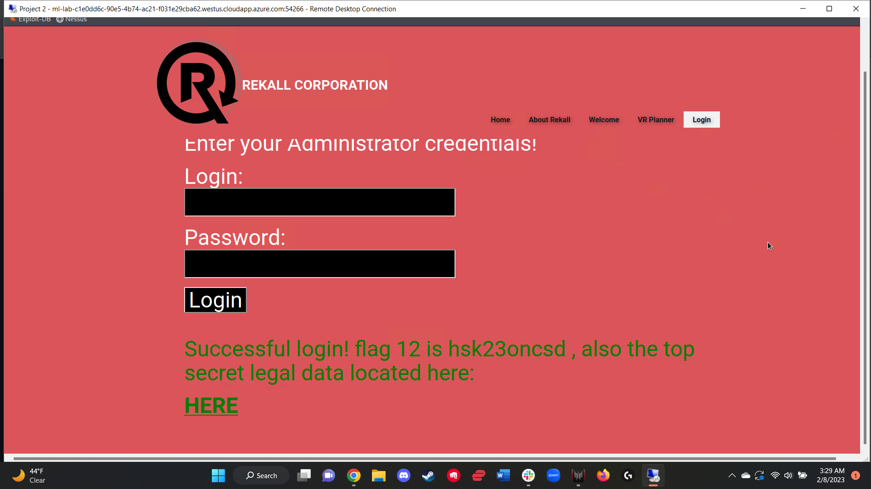

From the robots.txt web page, found the hidden web page Souvenirs.php. Using URL manipulation, I was able to access this page without issue. From here, I clicked the link present on the page and saw how the URL once again changed to reflect the new message present on the page. The URL Souvenirs.php?message=CALLUSNOW was used to exploit a php injection vulnerability. Inserted a payload into the URL, thus generating flag 13 (figure 14).

Payload used: Souvenirs.php?message=””-system(“ls”)

Figure 14:

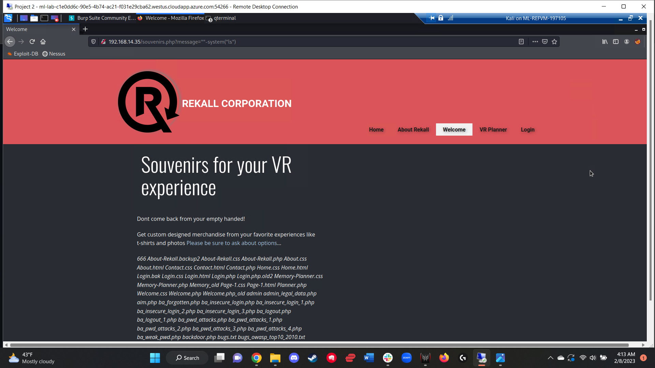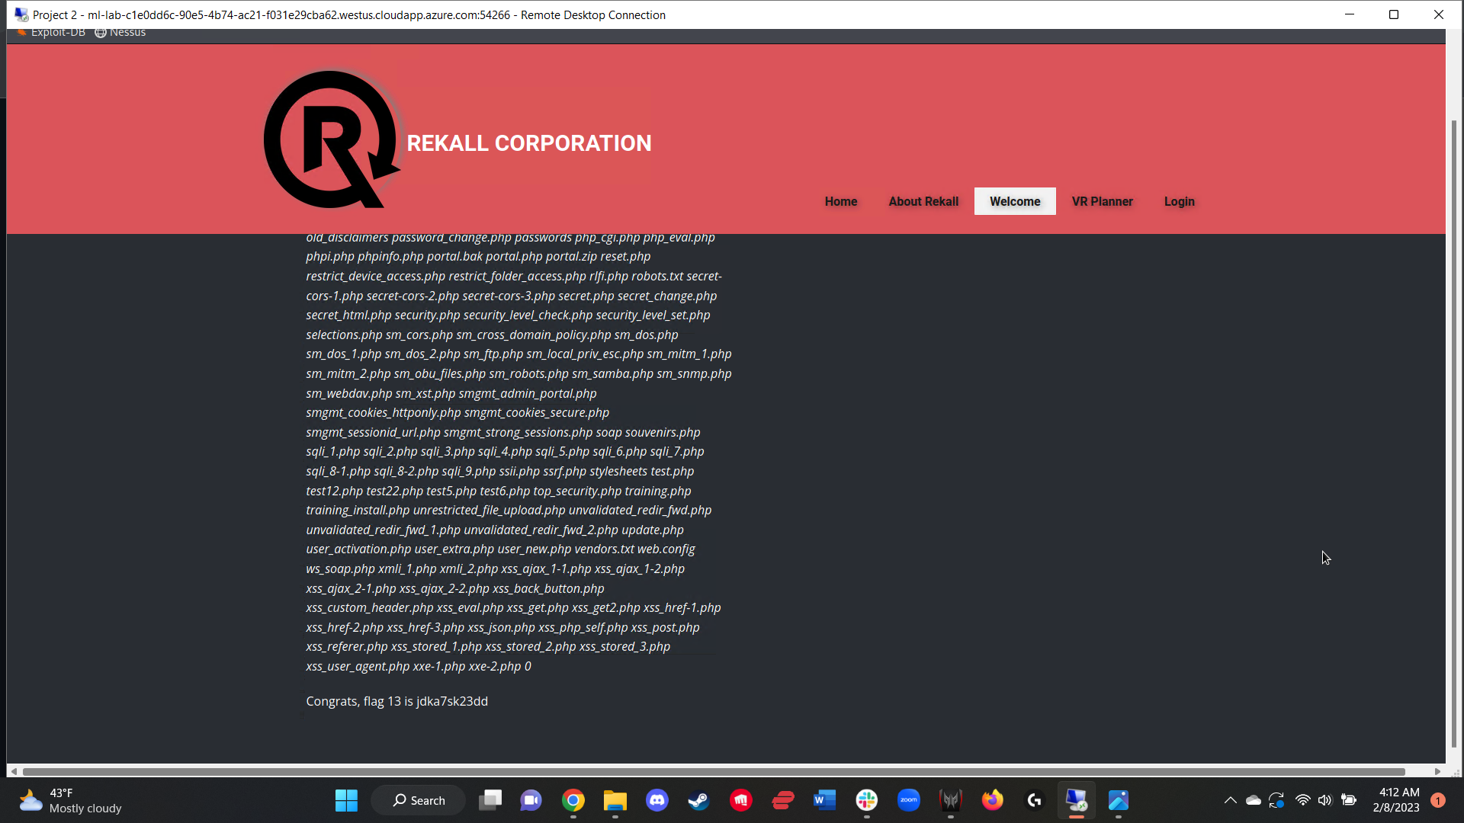

After brute forcing the login for user “melina”, I gained access to the restricted web page: Admin_legal_data.php?admin=0. The page was locked to admins only, but the admin ID was visually identifiable in the URL. In order to find the correct admin ID, I accessed the admin_legal_data.php files by loading the contents of the page as a .php file via URL manipulation from the disclaimer.php?page=disclaimer_2.txt and changing it to disclaimer.php?page=/var/www/html/admin_legal_data.php. The contents of the .php file was not visible from the rendered web page, but after inspecting the HTML page source, I was able to find the php script and locate the necessary admin ID (87) to successfully access the admin_legal_data.php web page (figure 15).

Using the correct admin ID (87) and inputting it into the URL in place of the incorrect admin ID, I was able to access the admin only web page that contained flag 14 (figure 16).

Figure 15:  
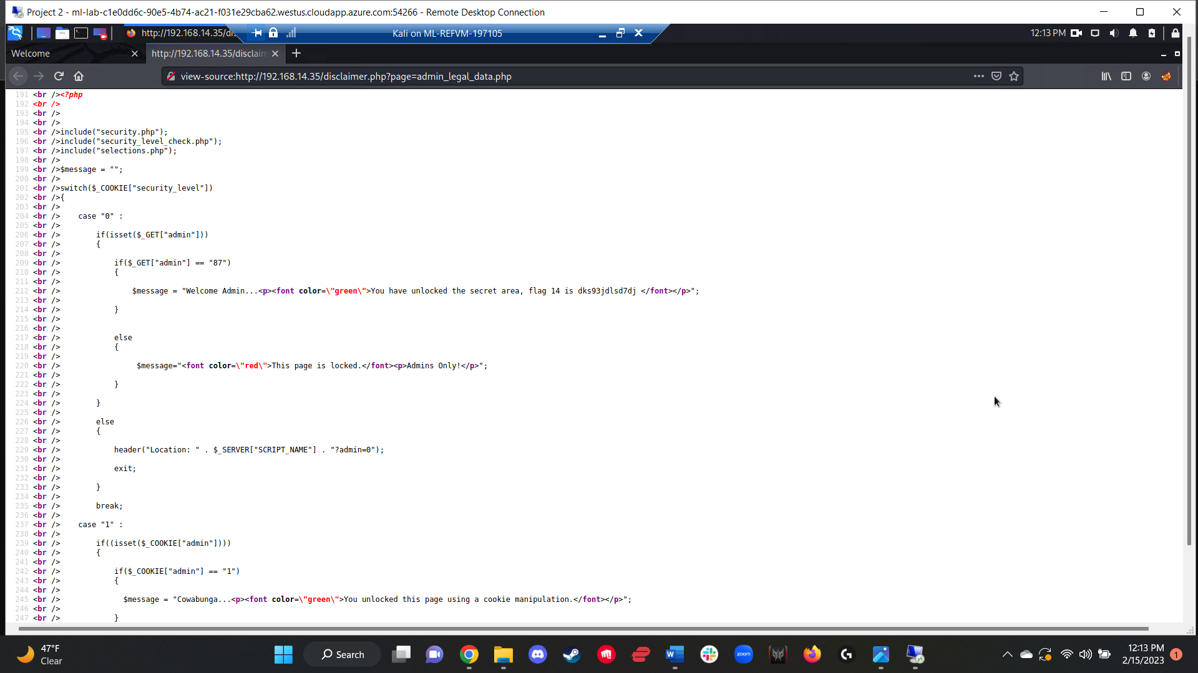

Figure 16:  
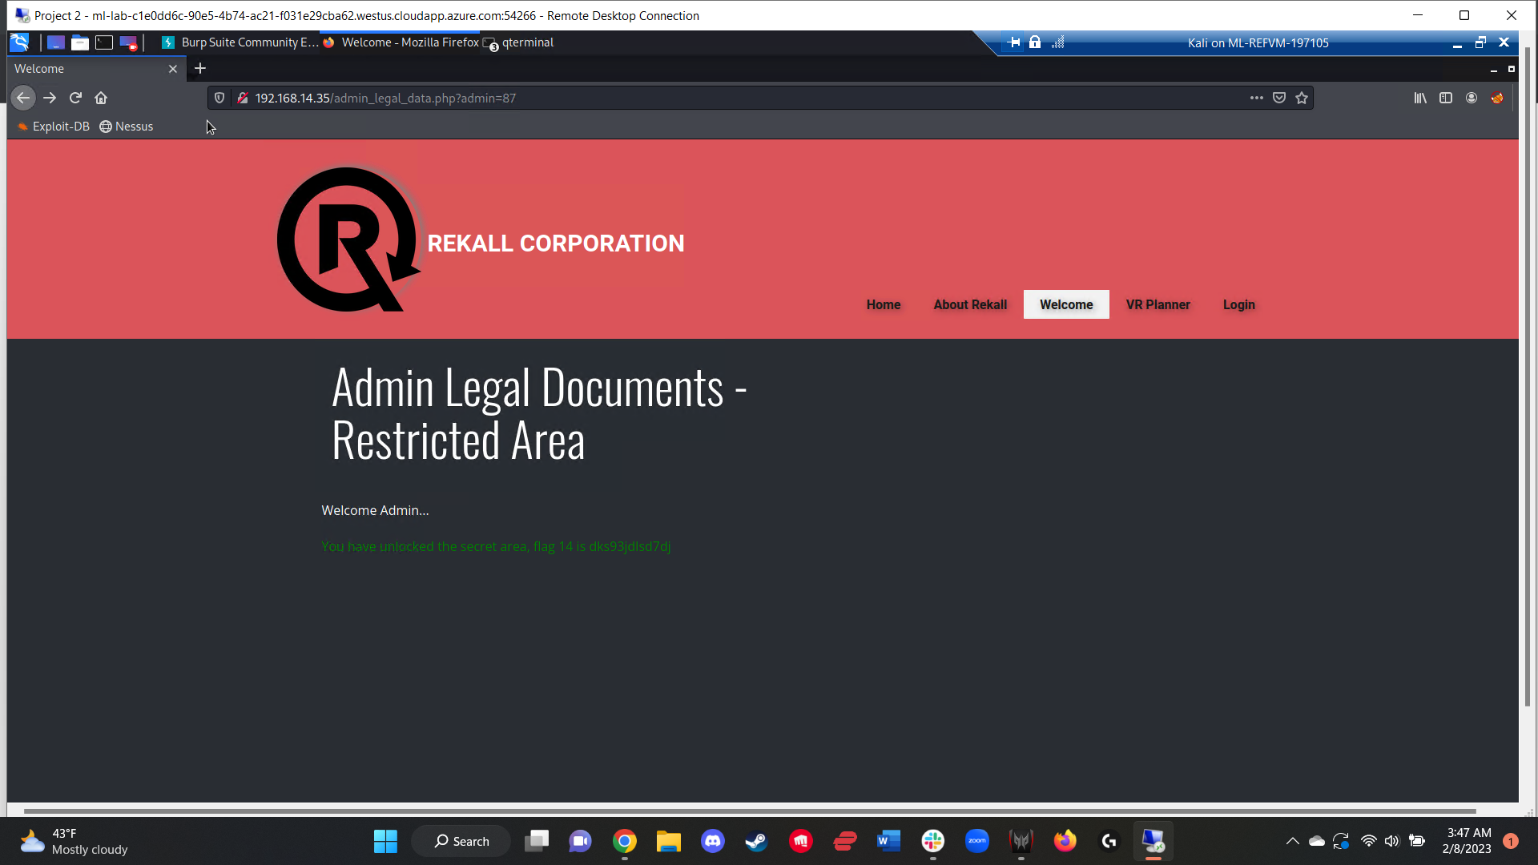

In order to access the final flag on the web application, I was able to once again manipulate the URL from the disclaimer.php?page=disclaimer_2.txt in order to access the disclaimer.php?page=/old_disclaimers/disclaimer_1.txt page to generate flag 15 (figure 18). I located this particular page after reviewing the contents of the “ls” command from the previous php injection and locating the old_disclaimers directory (figure 17).

Figure 17:  
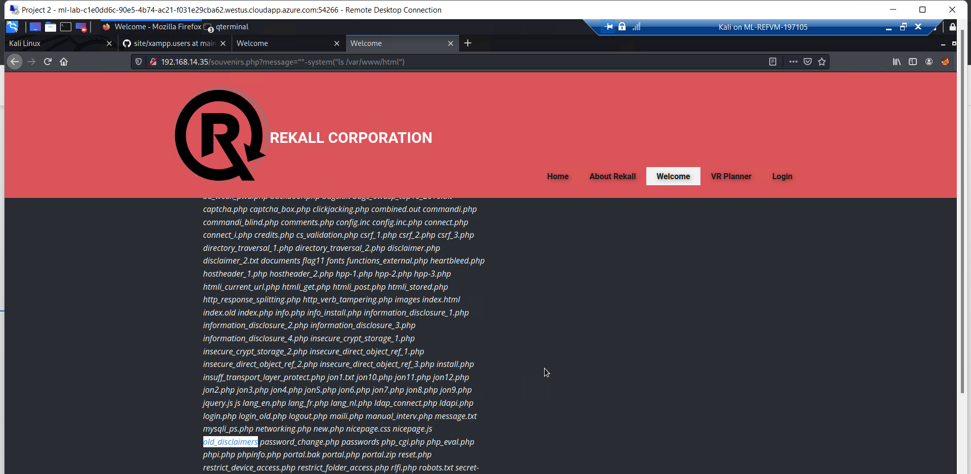

Figure 18:  
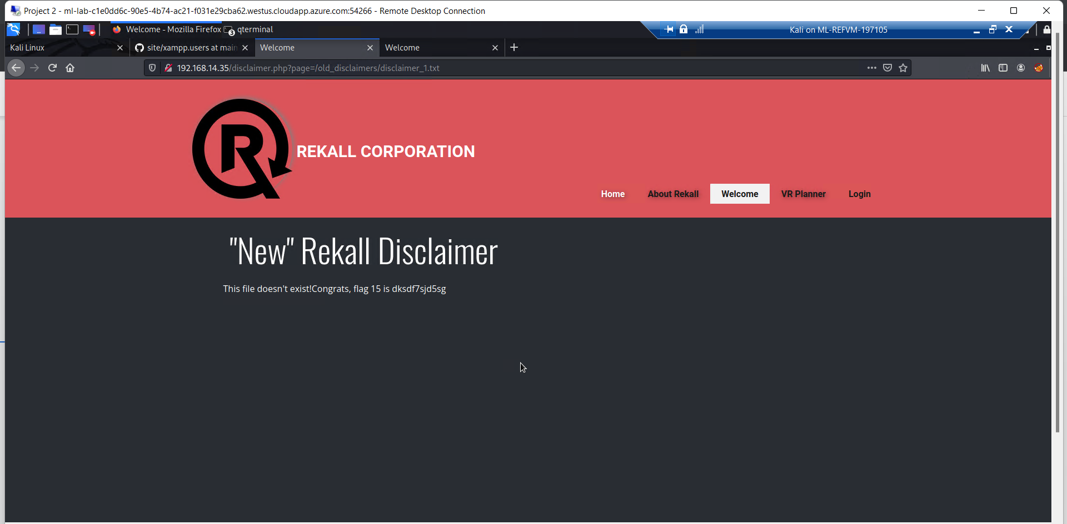

With the conclusion of the penetration test on the web-application, I transitioned into a targeted attack against the Rekall Corporation’s linux server, that had a domain name of totalrekall.xyz.

I began this attack by using the tool OSINT to locate information on the WHOIS domain for totalrekall.xyz. After a successful search, I found both the flag and the SSHuser, Alice (figure 19).

Figure 19:  
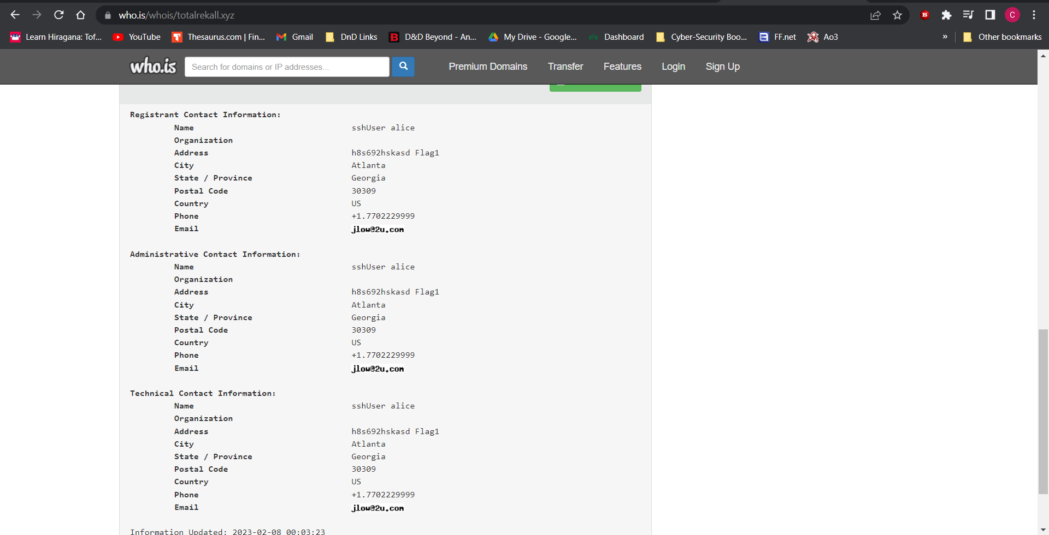

Following this, I conducted a simple *nmap* scan of totalrekall.xyz, in order to determine the IP address of the domain (figure 20). The resulting IP of 34.102.136.180 was flag 2.

Figure 20:  
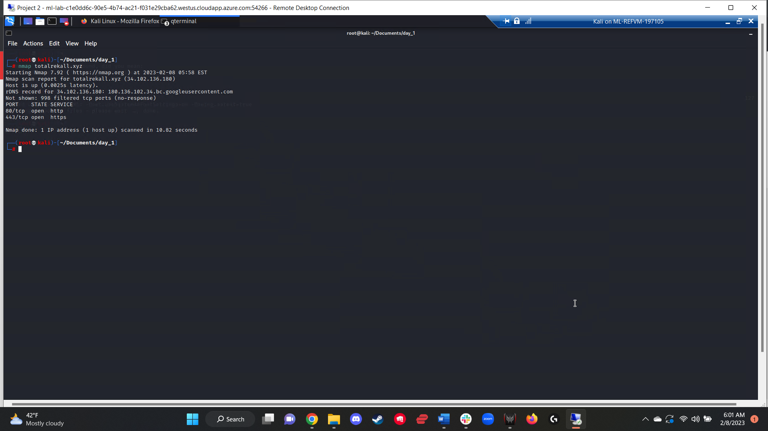

In order to find flag 3, I utilized the tool crt.sh and search totalrekall.xyz, successfully locating the flag (figure 21).

Figure 21:  
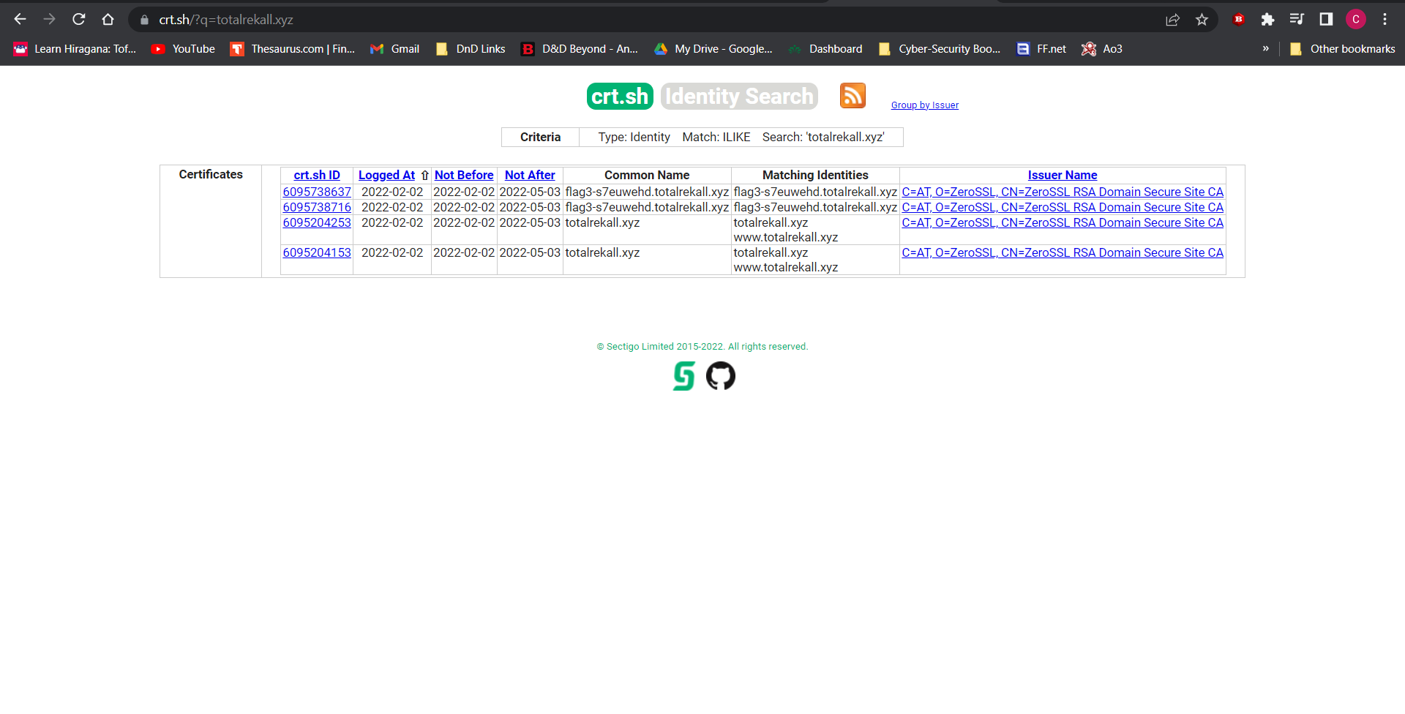

After being provided with a network (198.168.13.0/24), I ran an *nmap* scan on said network to determine how many hosts were up and available, getting a result of five hosts (not including the one I was scanning from), which was also flag 4 (figure 22) The available hosts were:  
198.168.13.10  
198.168.13.11  
198.168.13.12  
198.168.13.13  
198.168.13.14  
Immediately following this, I ran a second aggressive nmap scan to learn more about the processes being run on each available host, determining that the host that was running Drupal was 198.168.13.13, with said IP address being flag 5 (figure 23).

Figure 22:  
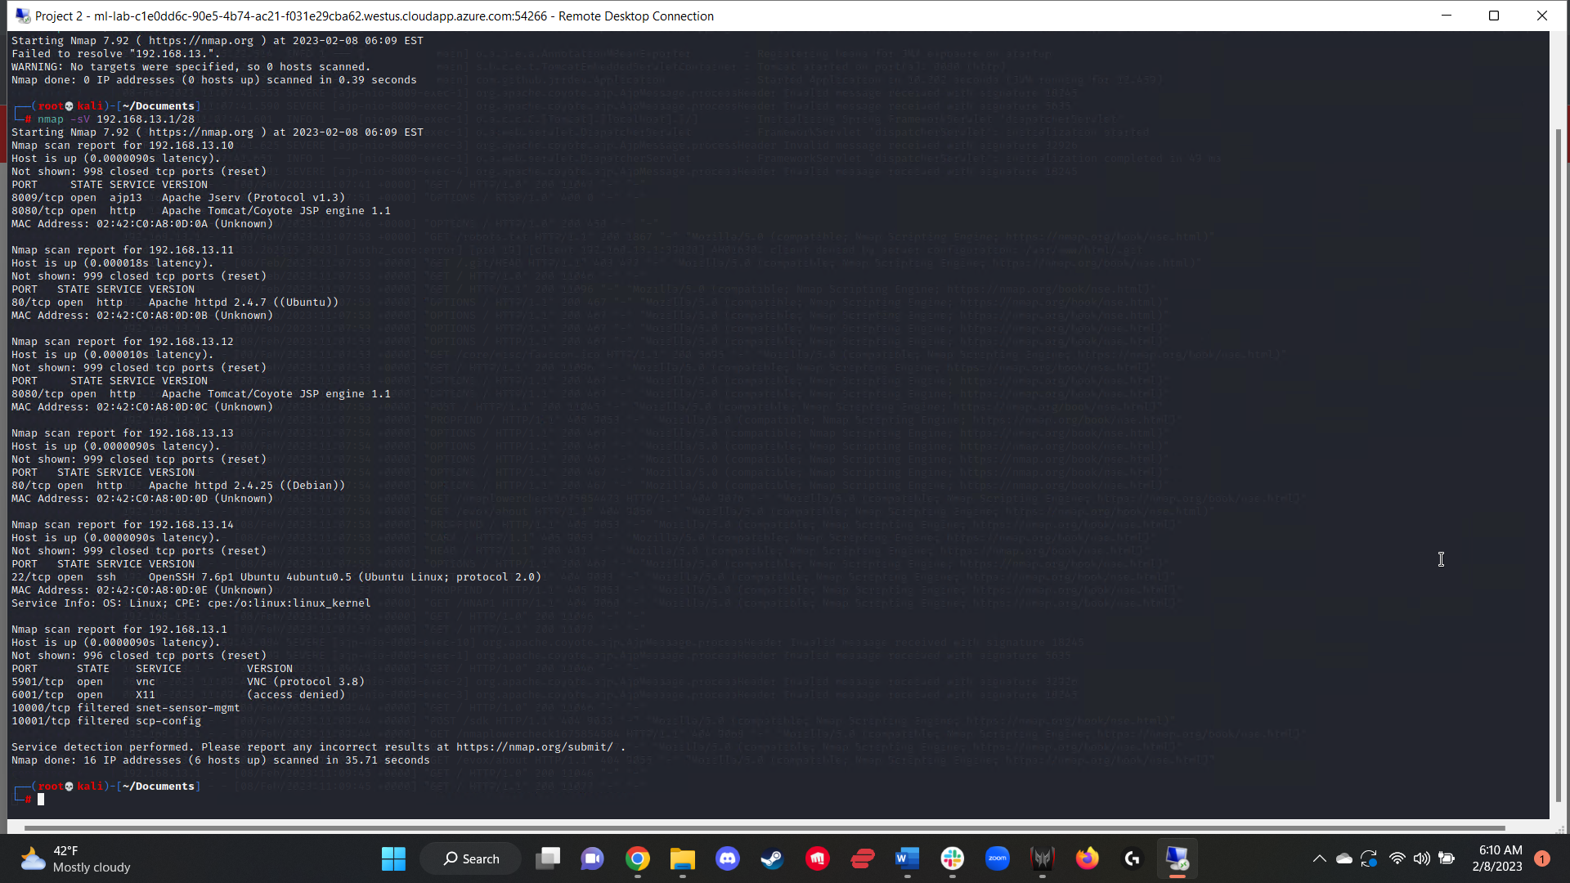

Figure 23:  
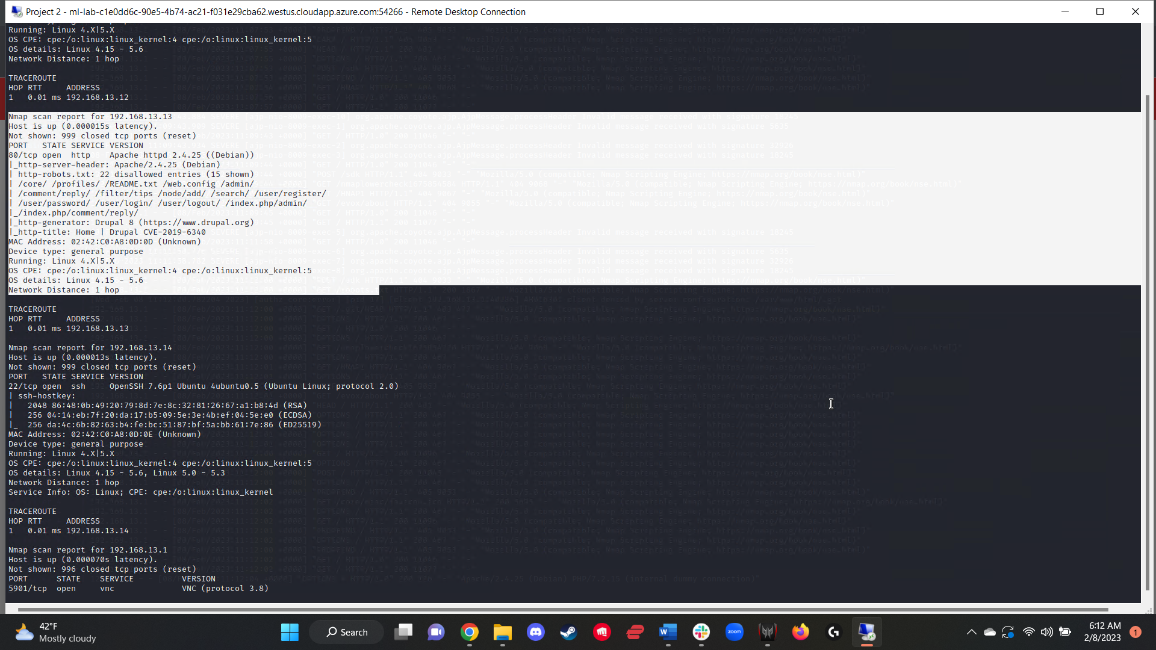

I then ran a full Nessus scan against the five discovered hosts, and in order to find flag 6, I honed in on 198.162.13.12. The Nessus scan revealed a critical vulnerability related to Apache Struts with the ID number of 97610, which was also flag 6 (figure 24).

Figure 24:  
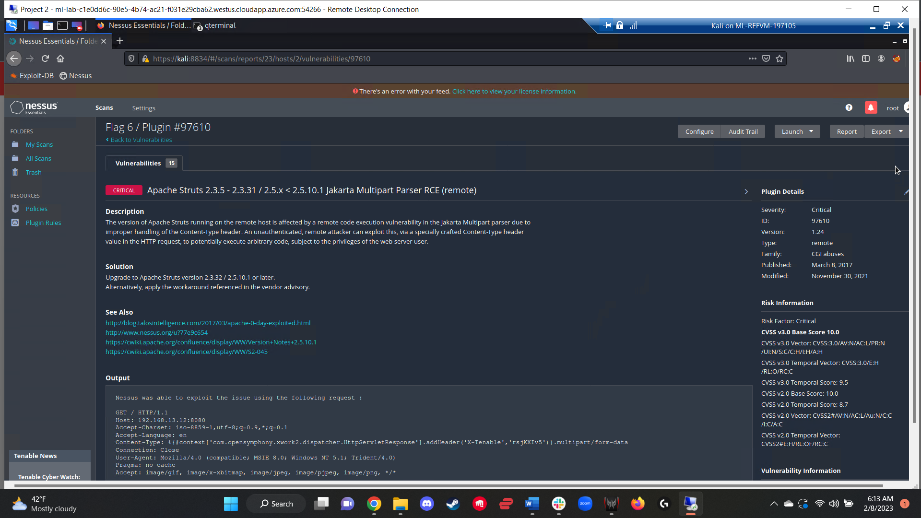

To find flag 7, I utilized a Metasploit exploit to target a vulnerability on the 198.162.13.10 server that was revealed by the full Nessus scan in concert with the aggressive nmap scan. From this, I used the *tomcat_jsp_upload_bypass* module to generate a meterpreter session. Once the meterpreter session had been established, I accessed the root directory and searched for hidden files, revealing flag 7. (Figures 24 and 25).

Figure 24:  
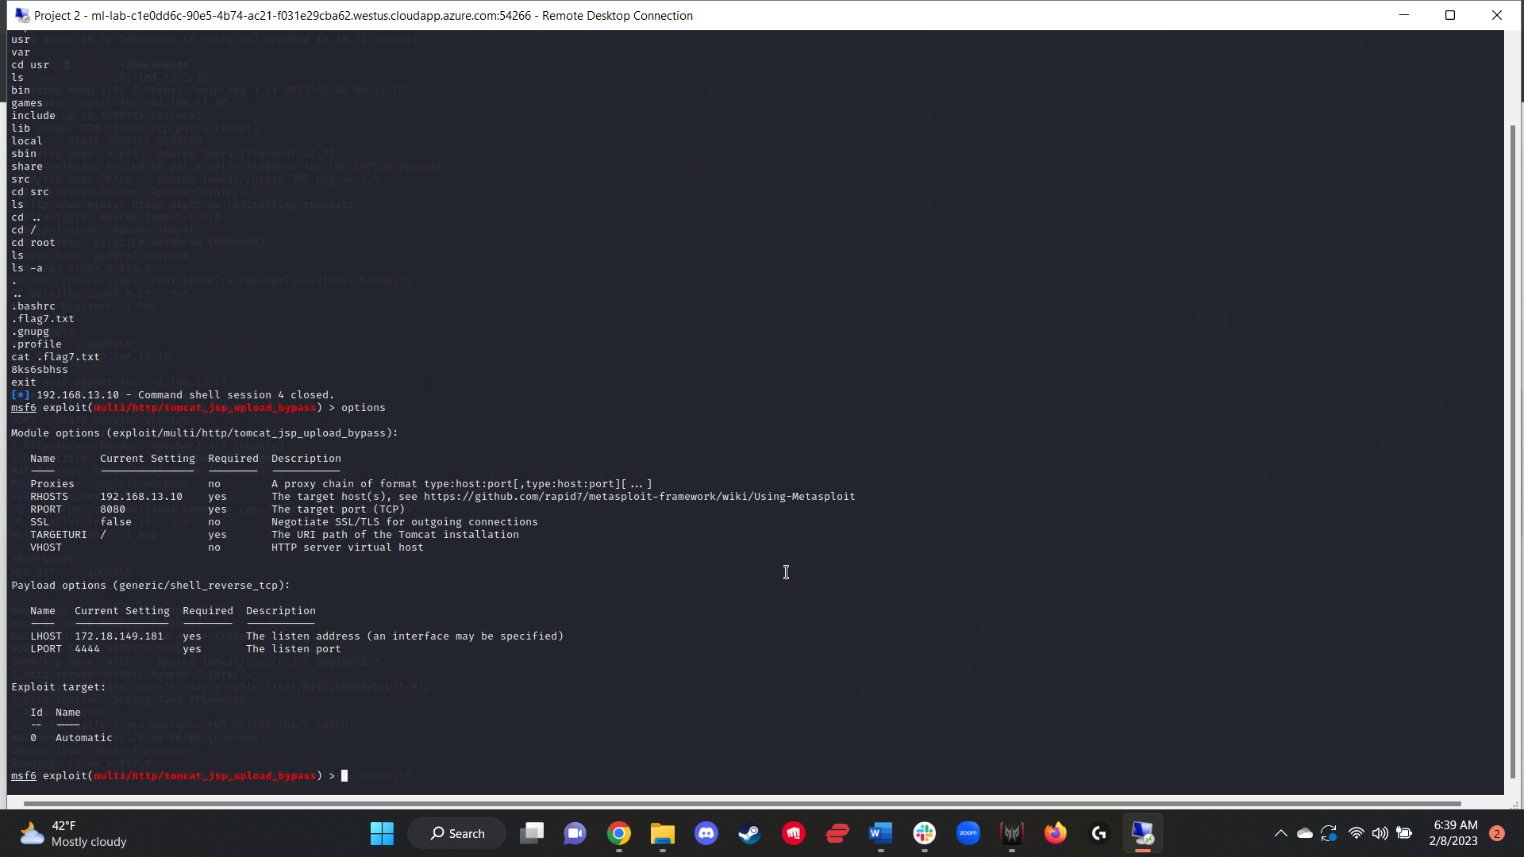

Figure 25:  
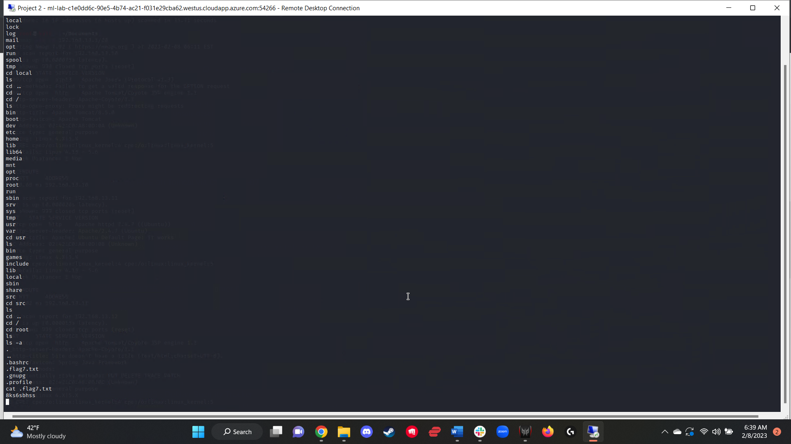

I then targeted the server 192.168.13.11 with an exploit that would utilize Shellshock to exploit a vulnerability revealed by the Nessus scan. I utilized the *apache_mod_cgi_bash_env_exec* Metasploit module to target the previously specified host, along with the targeturi provided (figure 26). Once a meterpreter session had been established, I searched the /etc/sudoers file and located flag 9 (figure 27).

Figure 26:  
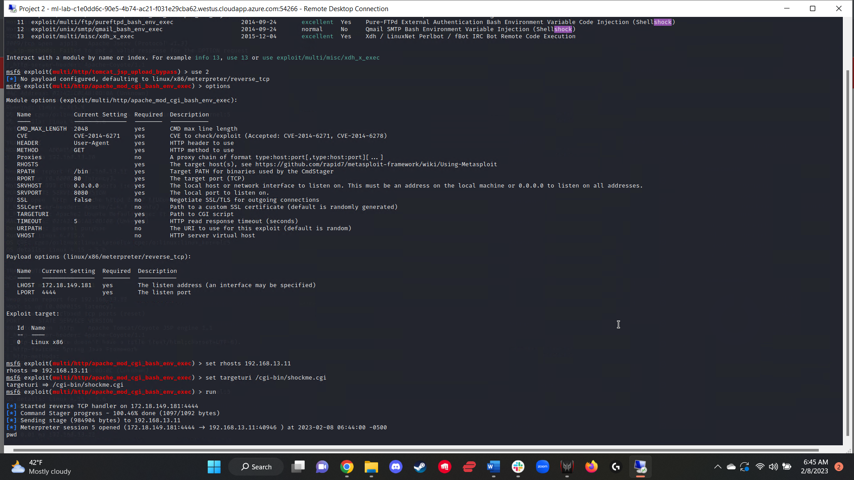

Figure 27:  
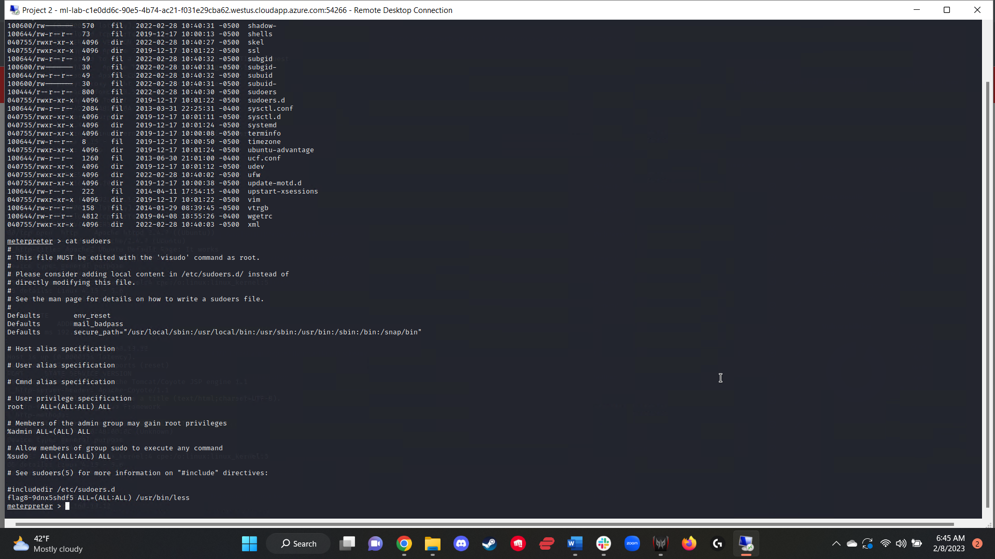

On the same server in which I located flag 8, I continued searching through the various directories and ended up locating flag 9 within the /etc/group file (figure 28).

Figure 28:  
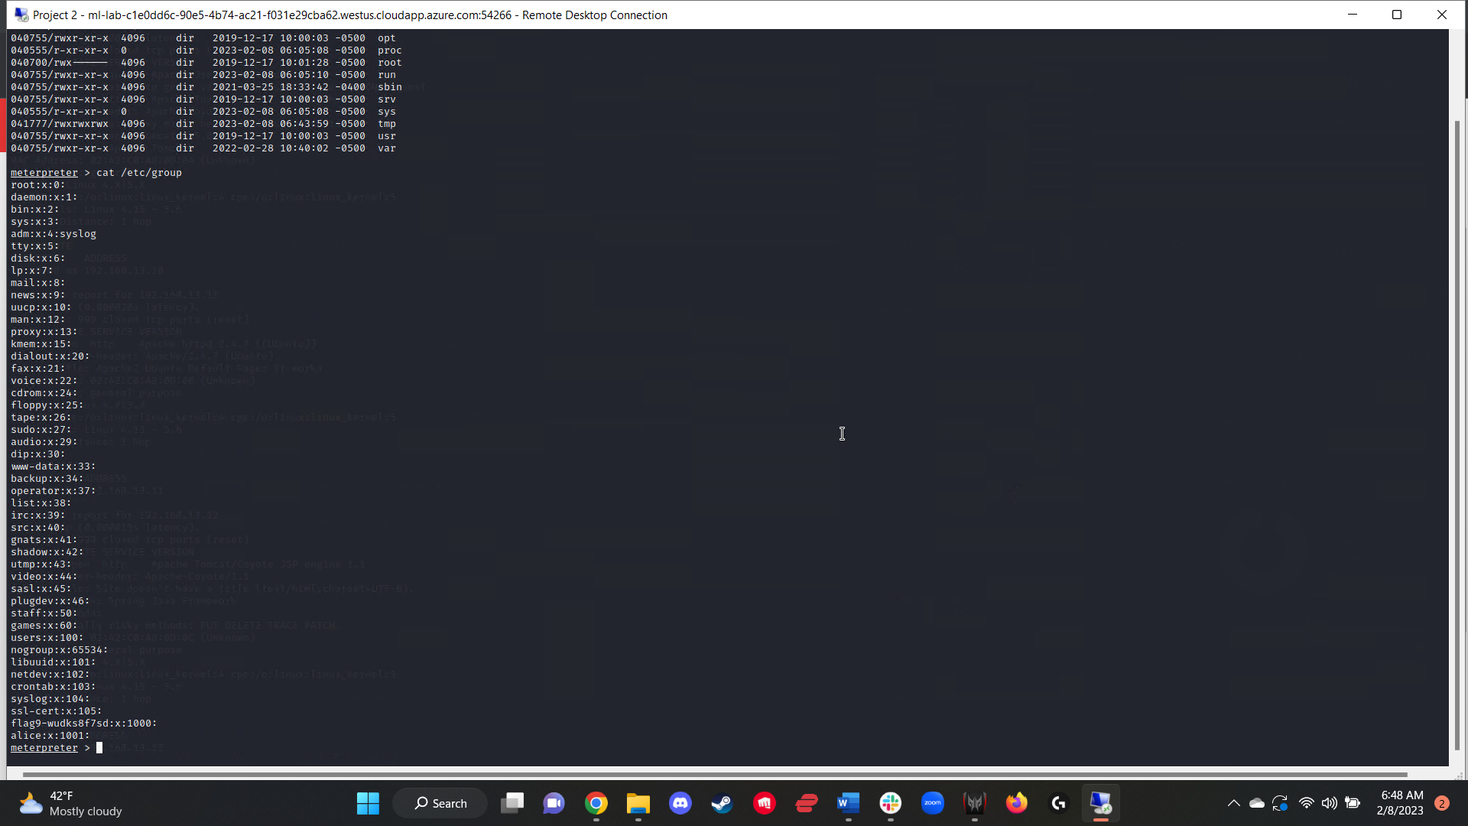

Once again, thanks to the results of the Nessus scan, I targeted a vulnerability present on the 192.168.13.12 server using the Metasploit module *struts2_content_type_ognl* (figure 29). After setting the proper options and generating a meterpreter session, I changed to the root directory and found a zipped file labeled *flagisinthisfile.7z*. To access this zipped file, I simply used Meterpreter’s “edit” command on the file, revealing the contents that were still encrypted, but I was still able to view flag 10 (figures 30 and 31).

Figure 29:  
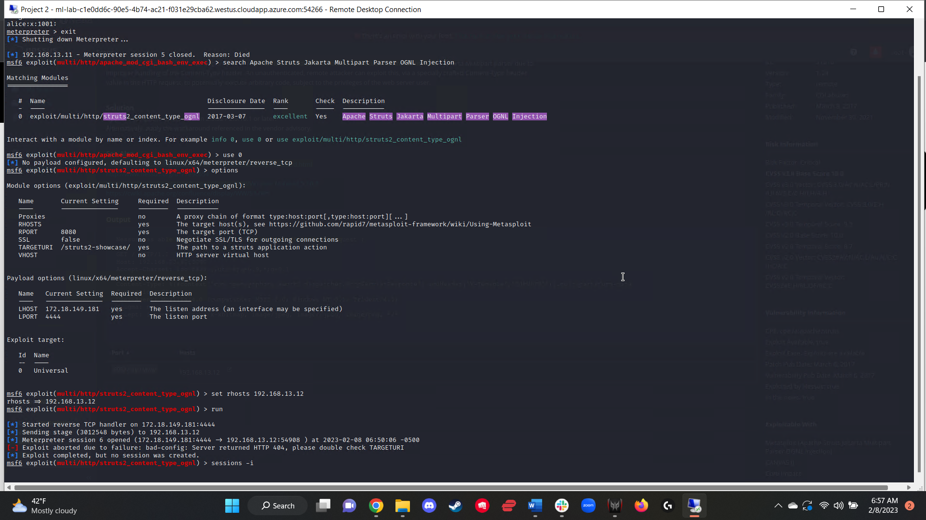

Figure 30: 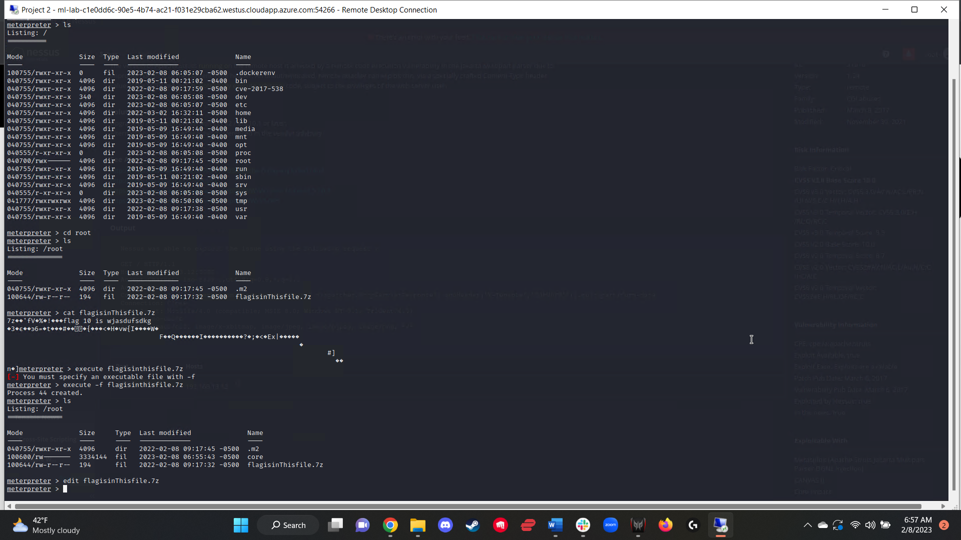

Figure 31:  
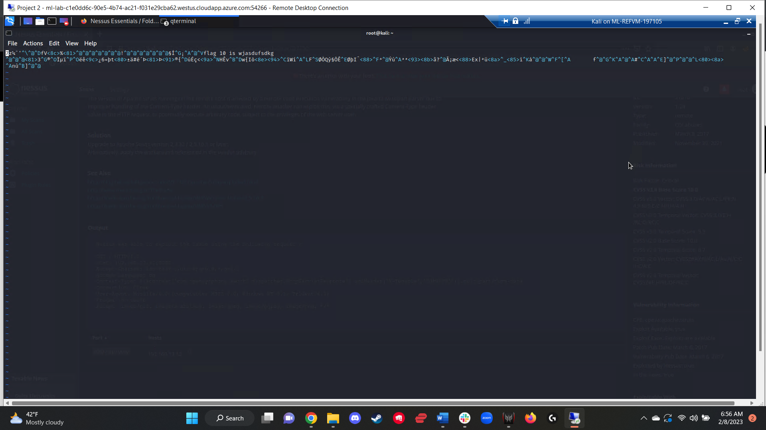

I then targeted the 192.168.13.13 server using a RCE exploit. After trying a series of exploits related to the vulnerabilities exposed via the Nessus scan, all of which failed, I changed tactics and utilized an exploit that would take advantage of the target server using Drupal, specifically the Metasploit module *drupal_restws_unserialize* (figure 32). After establishing a meterpreter session, I used the command *getuid* to learn the username, which was also flag 11 (figure 33).

Figure 32:  
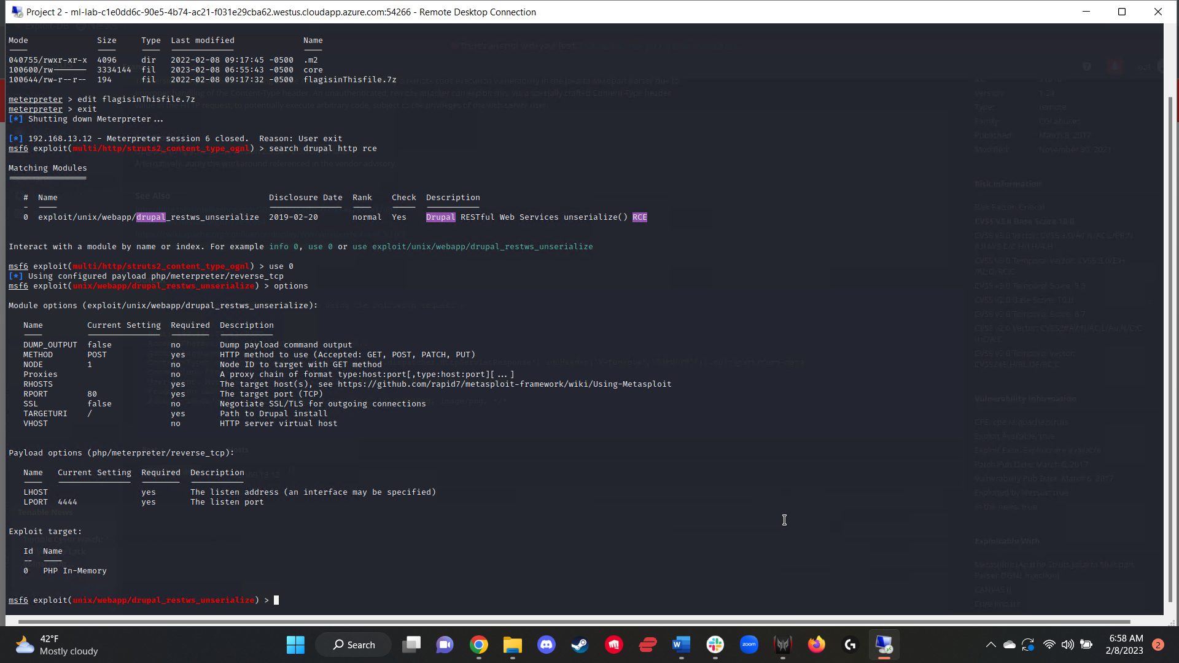

Figure 33:  
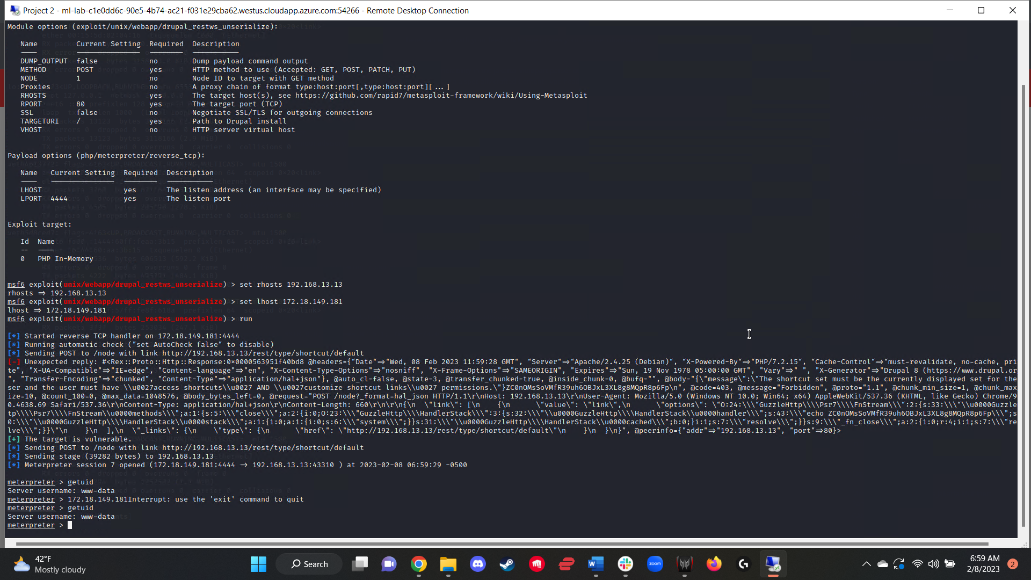

In order to find the final flag, I utilized the open port 22 on the 192.168.13.14 server to SSH into the server using the username “alice” identified during the WHOIS scan. I guessed the password “alice” as it was a match to the username. Once I was in the system, I exploited a privilege-escalation vulnerability to gain root access using the command *sudo -u#-1 bash*. After this, I navigated to the root directory and located flag 12 (figure 34).

Figure 34:  
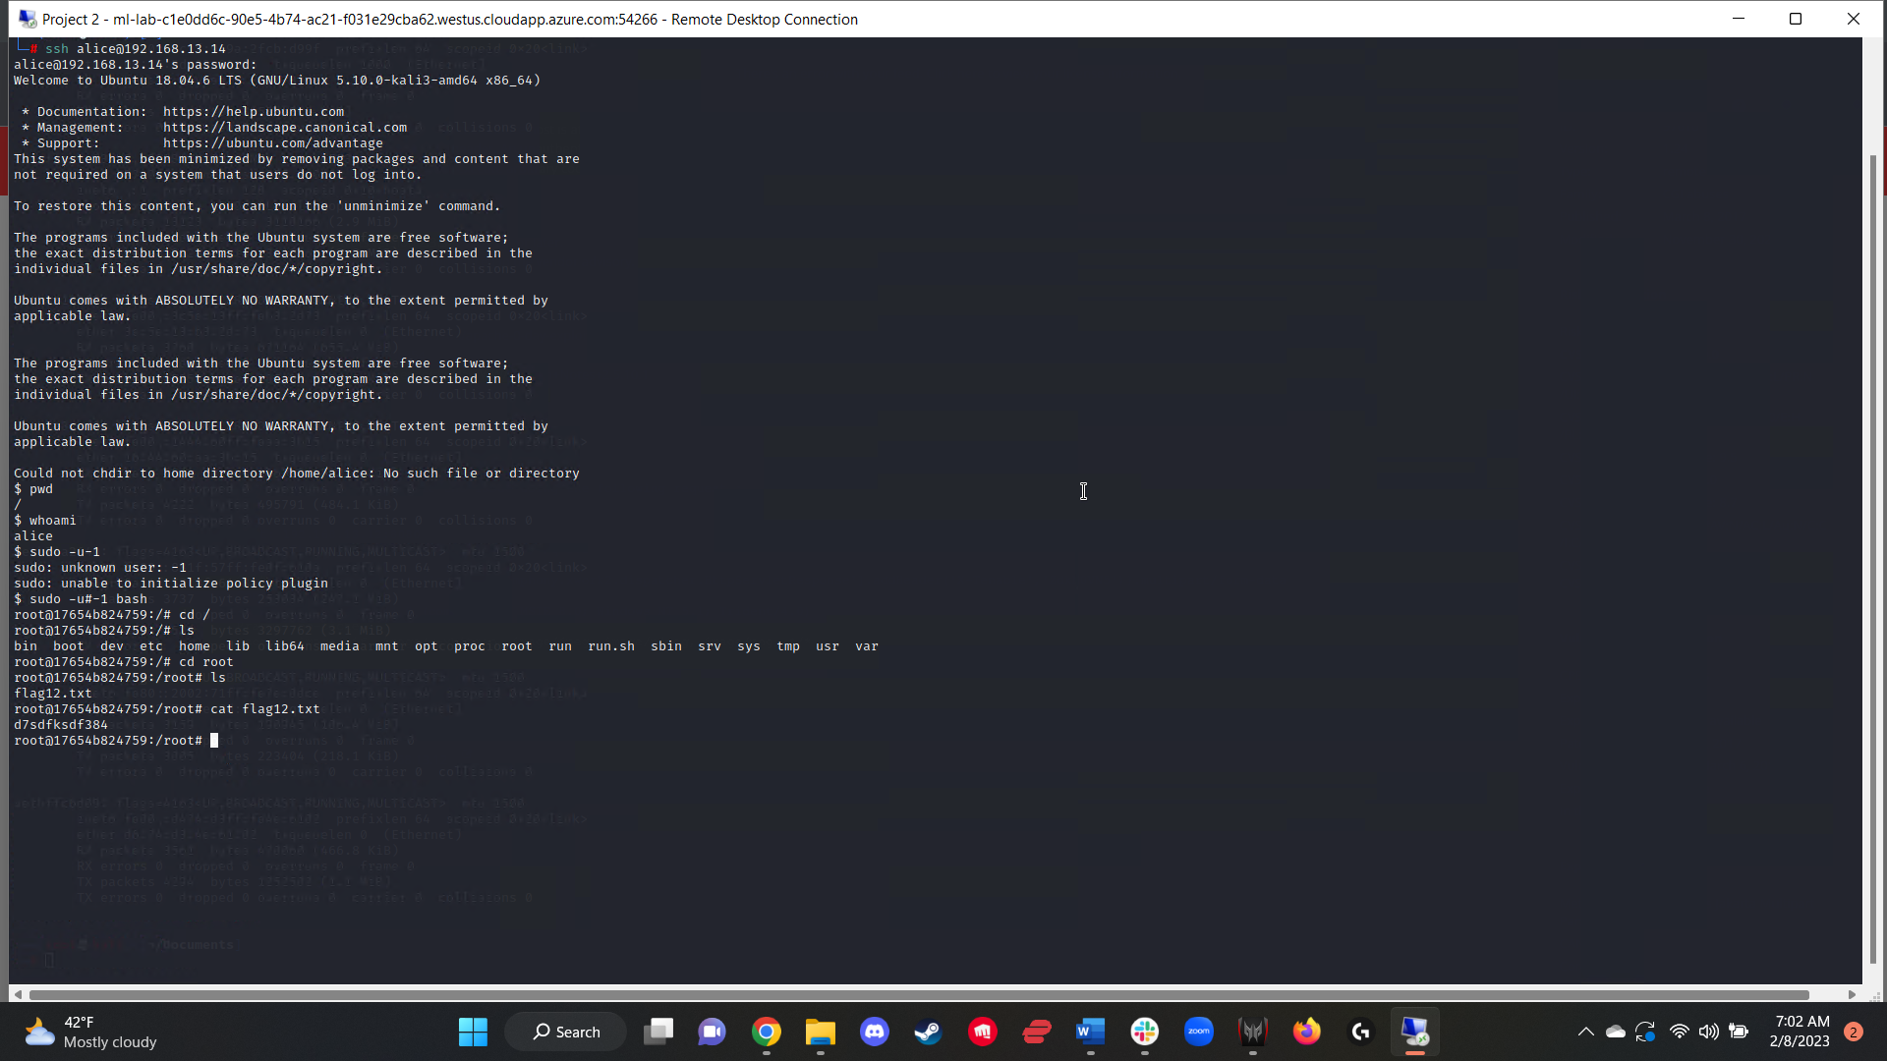

With the penetration test on the Linux servers complete, I transitioned into a targeted attack against the Windows servers.

I began this attack by searching through Github to locate a repository of the totalrekall.xyz site, and located sensitive credentials including a username and password hash (figure 35). Using this username and hash, I placed them into a .txt file and cracked the hash in order to get a plaintext password, which was also flag 1 (figure 36).

Figure 35:  
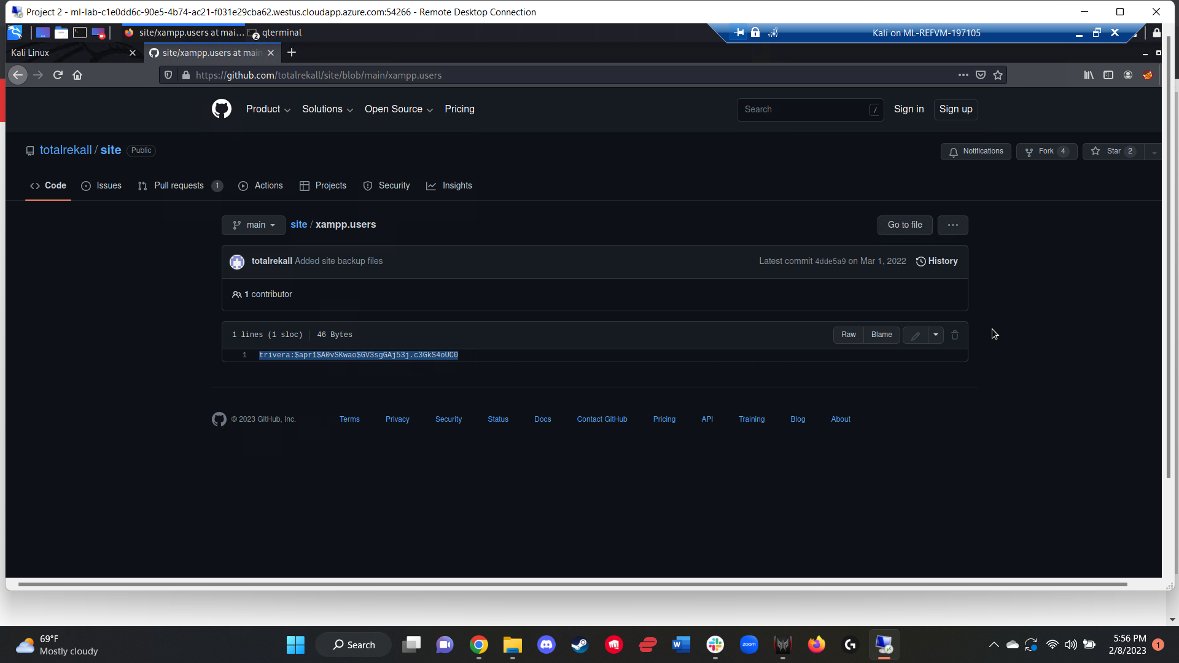

Figure 36:  
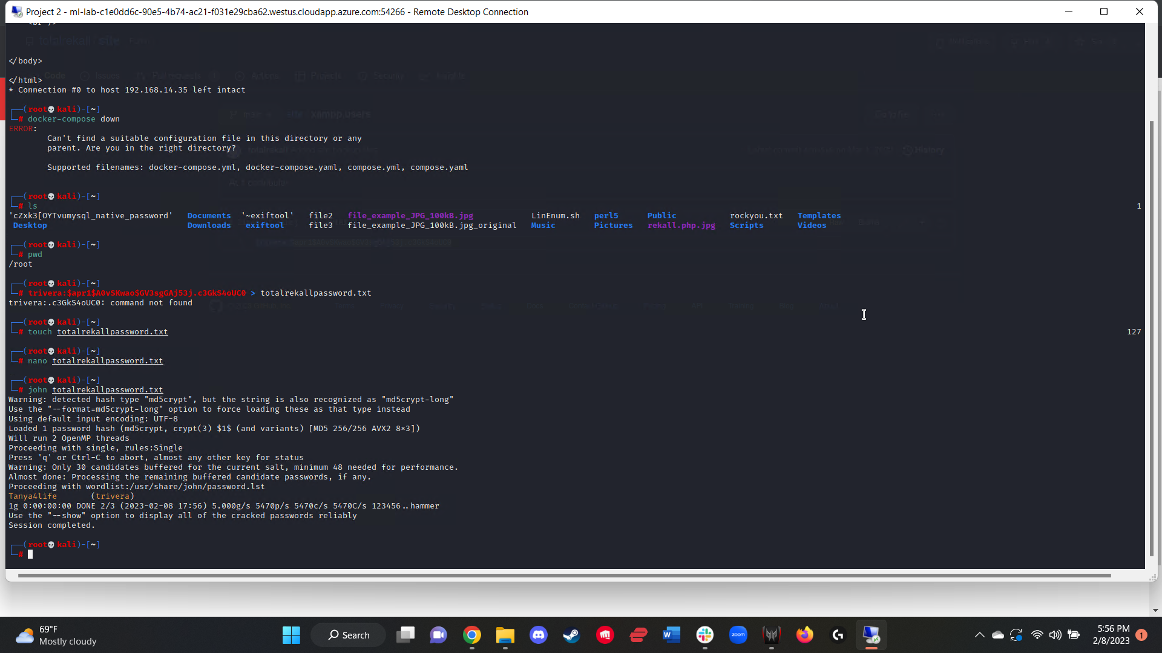

Using the provided Windows network subnet, I conducted an nmap scan that revealed two servers up and running:  
172.22.117.10  
172.22.117.20  
The nmap scan also revealed that the 172.22.117.20 server had an open HTTP port (figure 37). Using this, I entered the IP address into a browser and was able to access flag 2 (figure 38).

Figure 37:  
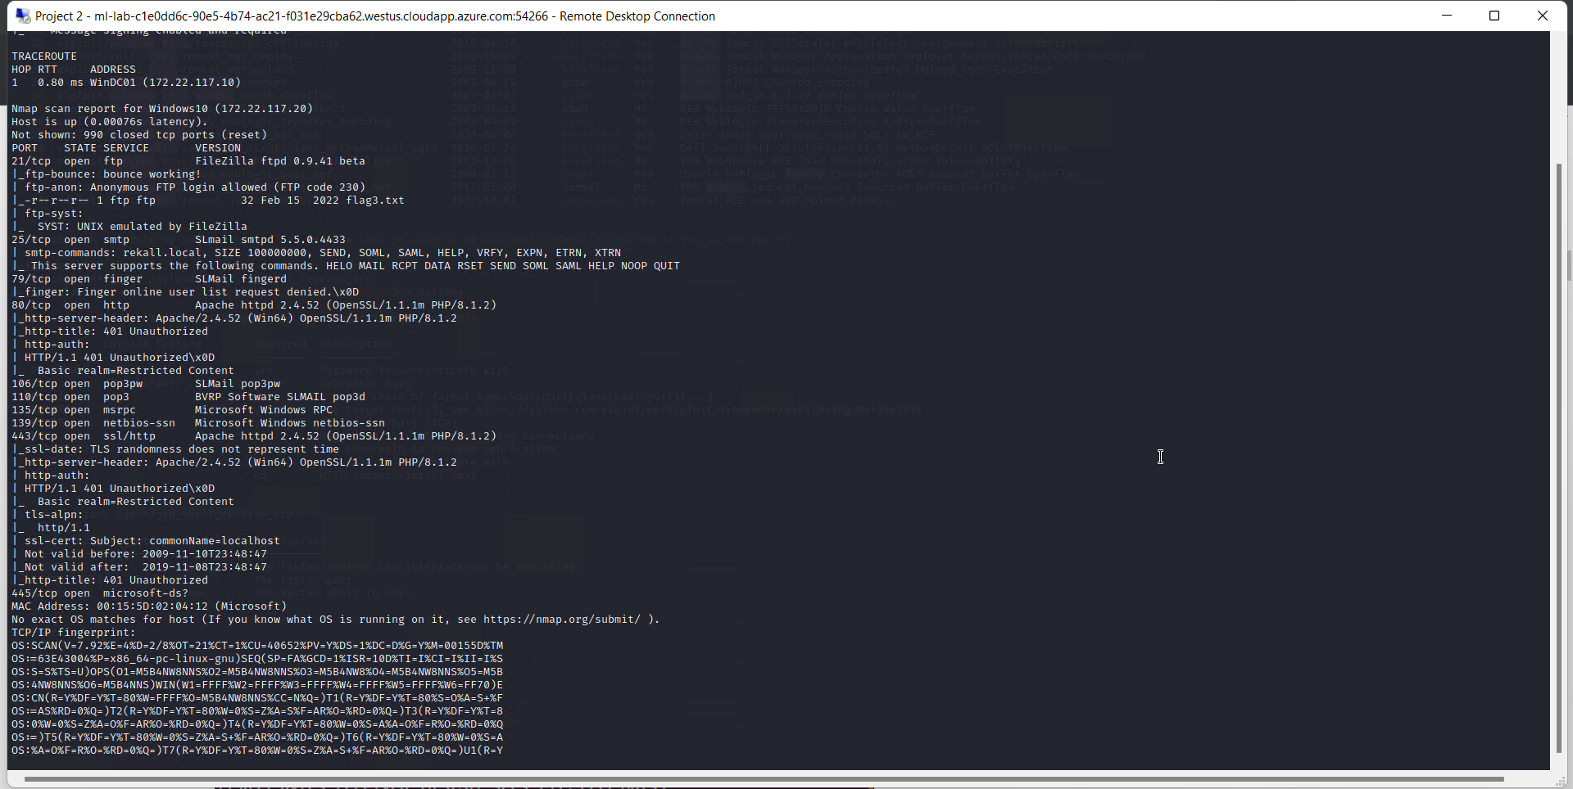

Figure 38:  
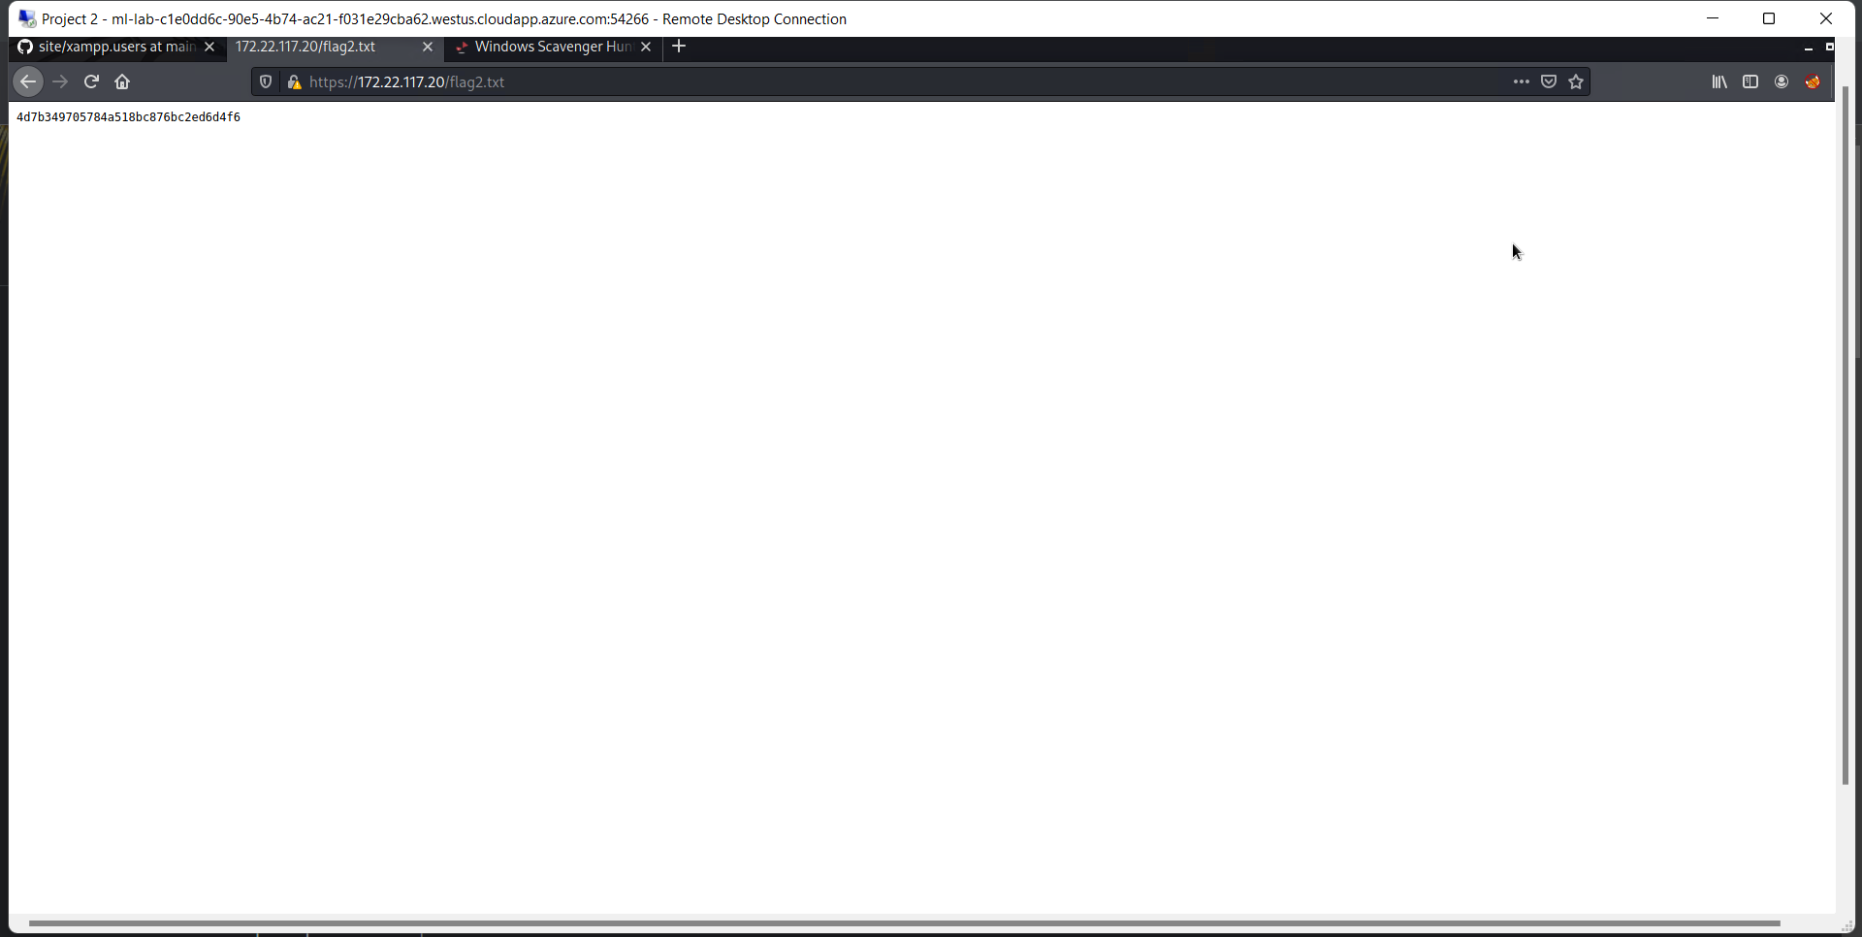

Utilizing the open port 21, I was able to FTP into the 172.22.117.20 server, login using anonymous as both a username and password, and download the flag3.txt file to my machine before reviewing the contents of the file to access flag 3 (figure 39).

Figure 39:  
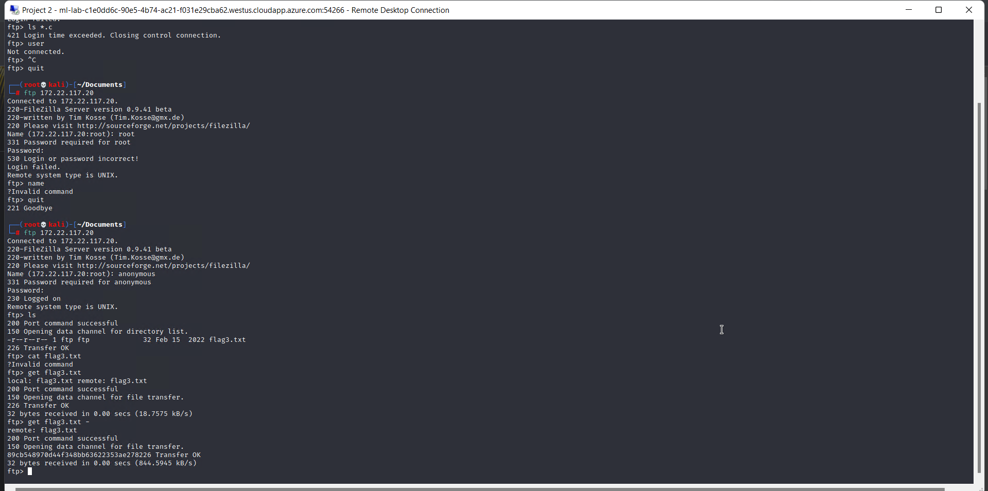

Due to the results of the aggressive nmap scan, I then chose to utilize an exploit related to the SLMAIL service using the Metasploit module *windows/pop3/seattlelab_pass* (figure 40). After establishing a meterpreter session using this exploit, I simply had to locate and review the contents of the flag4.txt file to locate flag 4 (figure 41).   
While on the same machine and session, I continued to search through the various directories using the hint provided and was able to locate flag 7 in the C:\Users\Public\Documents directory (figure 42).   
Still within the same machine, per the hint, I opened a shell and utilized the *schtasks /query* command to view the scheduled tasks and found that flag 5 was a task ready to run (figure 43). In order to access the flag itself, I utilized the same command with a series of switches (*schtasks /query /TN flag5 /FO list /v)* that revealed the details of the task itself and the contents of flag 5 located in the comments section (figure 44).  
After exiting the shell, I continued my exploit of this server by loading the *kiwi* extension, which then allowed me to run the command *lsa_dump_sam*, generating an output of usernames and hashes (figure 45). The contents of this dump was then saved to a .txt file, and after using *john* to crack the hashes, I got the usernames and plaintext passwords for multiple accounts, including “flag 6”, a user whose password was flag 6 (figure 46).

Figure 40:  
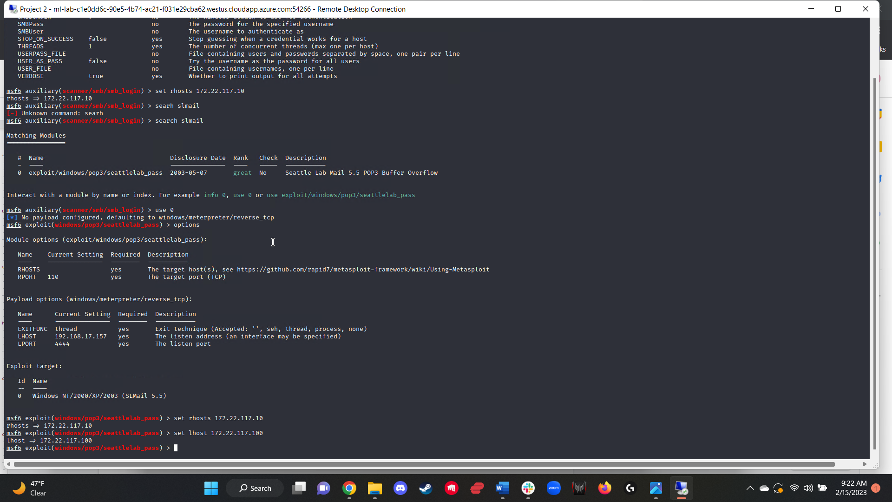

Figure 41:  
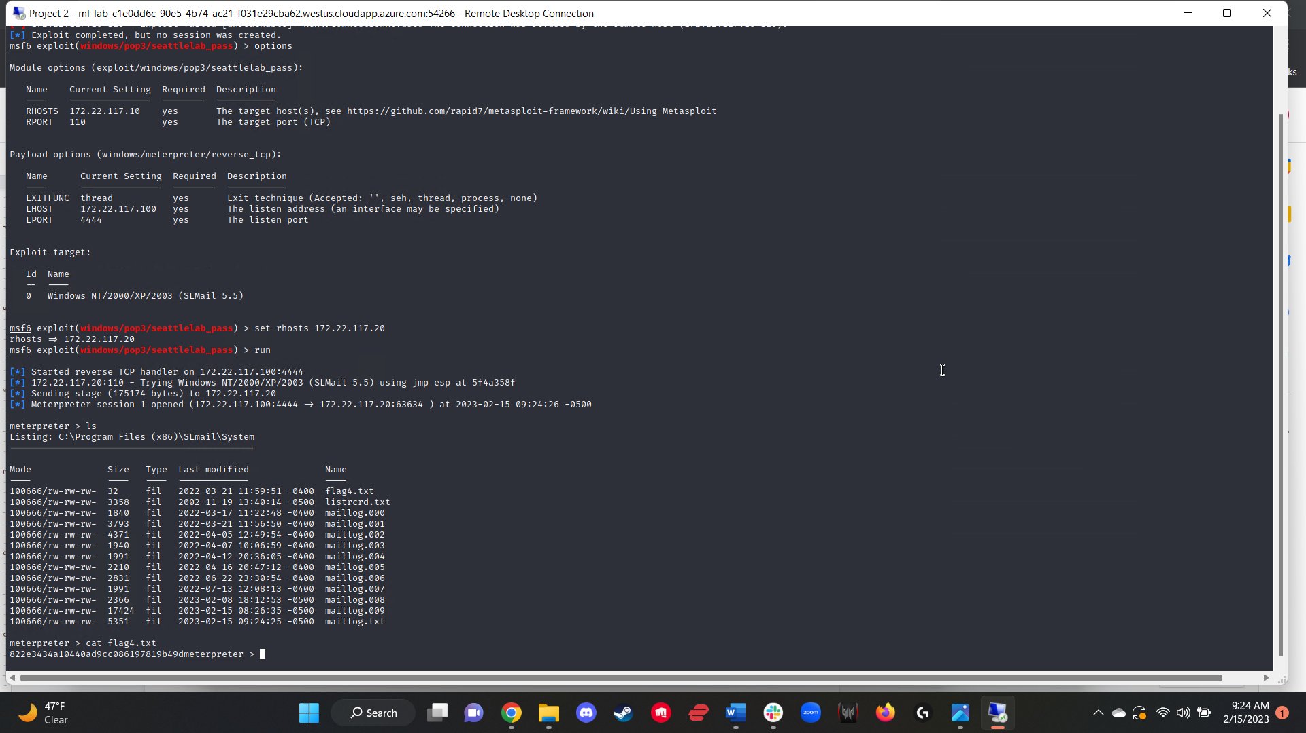

Figure 42:  
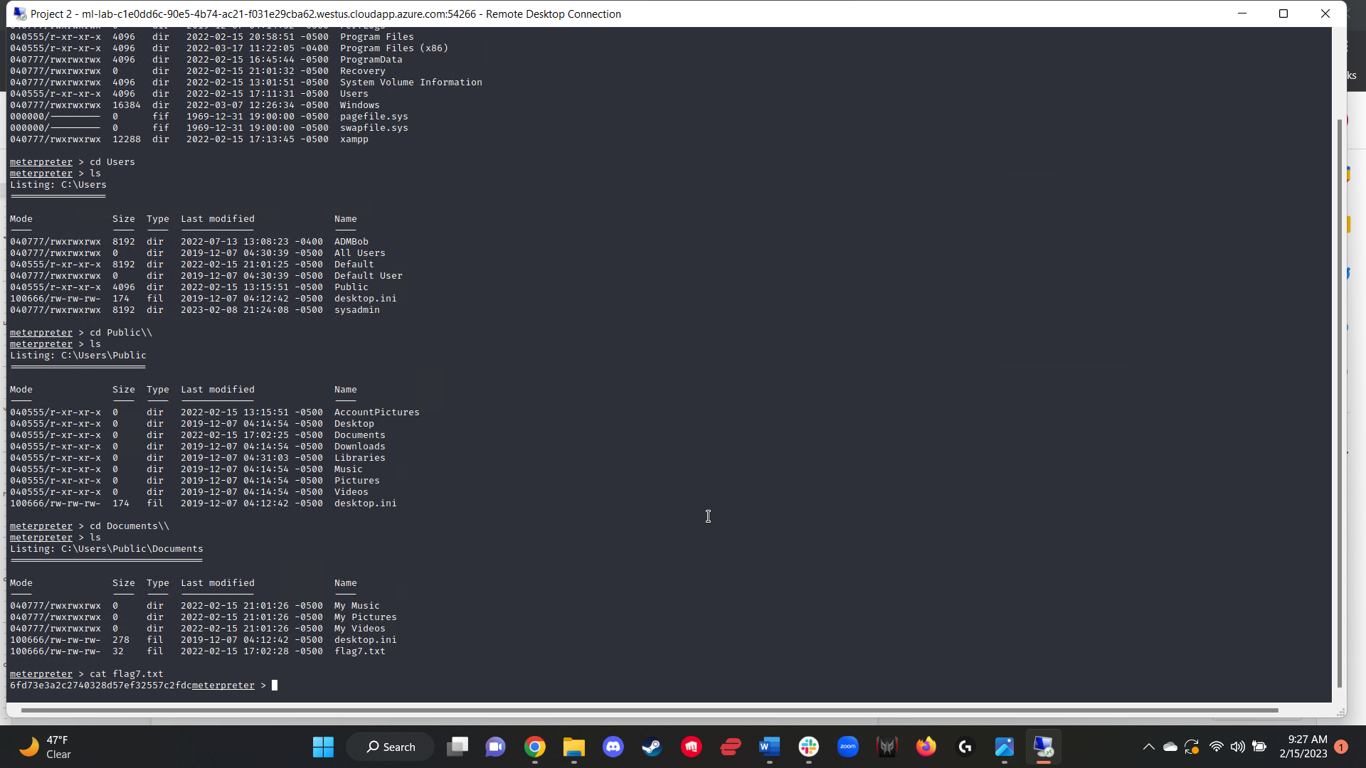

Figure 43:  
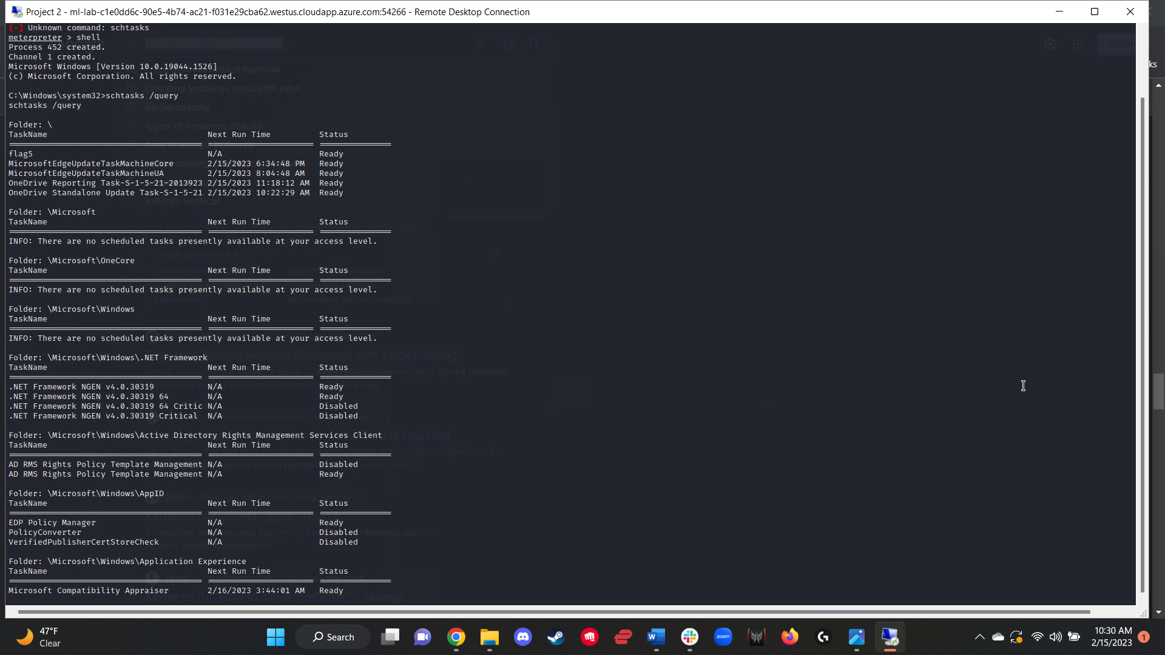

Figure 44:  
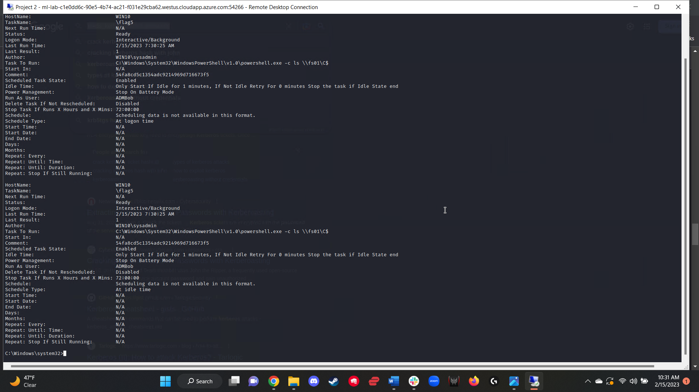

Figure 45:  
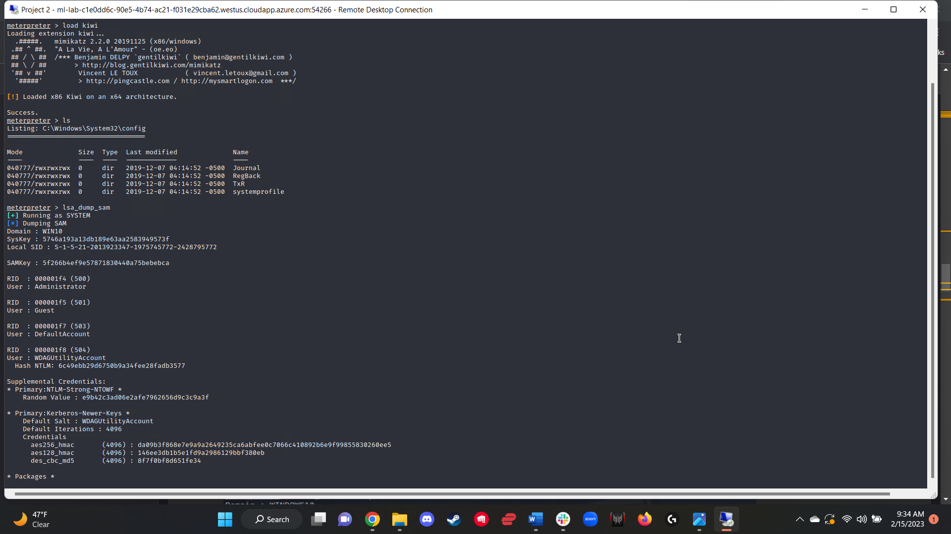

Figure 46:  
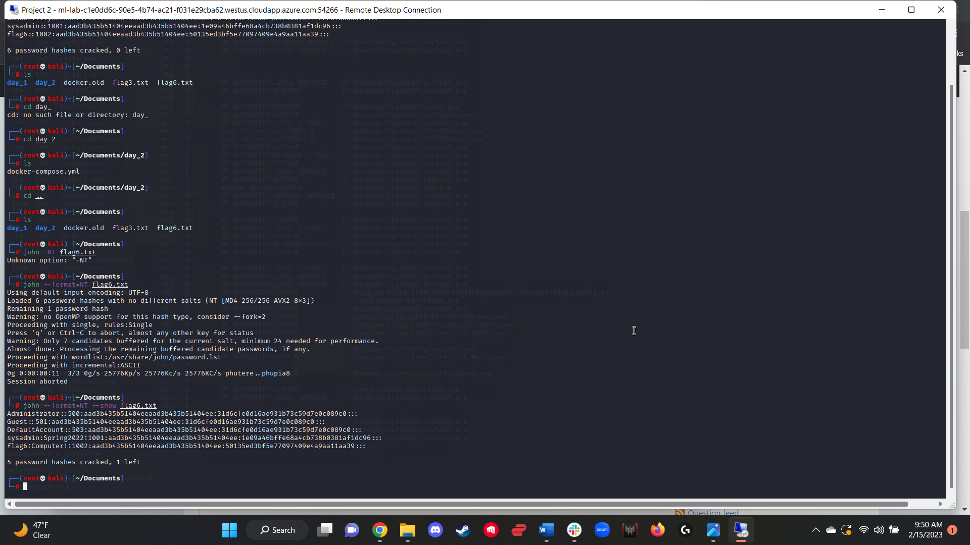

Once again utilizing the kiwi extension, I ran the *kiwi_cmd lsadump::cache* command and found that an administrator user with the username ADMBob had their credentials hashed (figure 47). Using this username and hash, I placed them into a .txt file and cracked the hash using *john*, cracking the password and thus gaining admin credentials for the 172.22.117.10 server (figure 48). Using these cracked credentials and the metasploit module *windows/smb/psexec* (figure 49), I was able to generate a meterpreter session and gain access to the system. Once in the system, I opened a shell and used the command *net user* to see a list of user accounts on the system, one of which was flag 8 (figure 50).

Figure 47:  
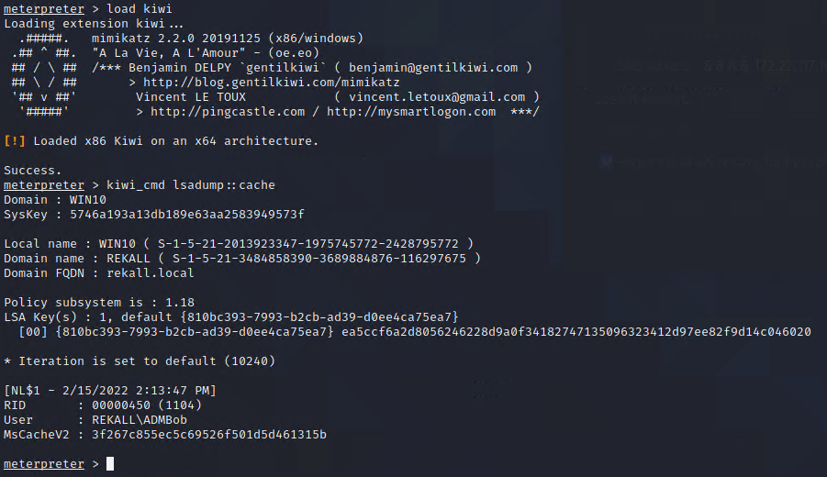

Figure 48:  
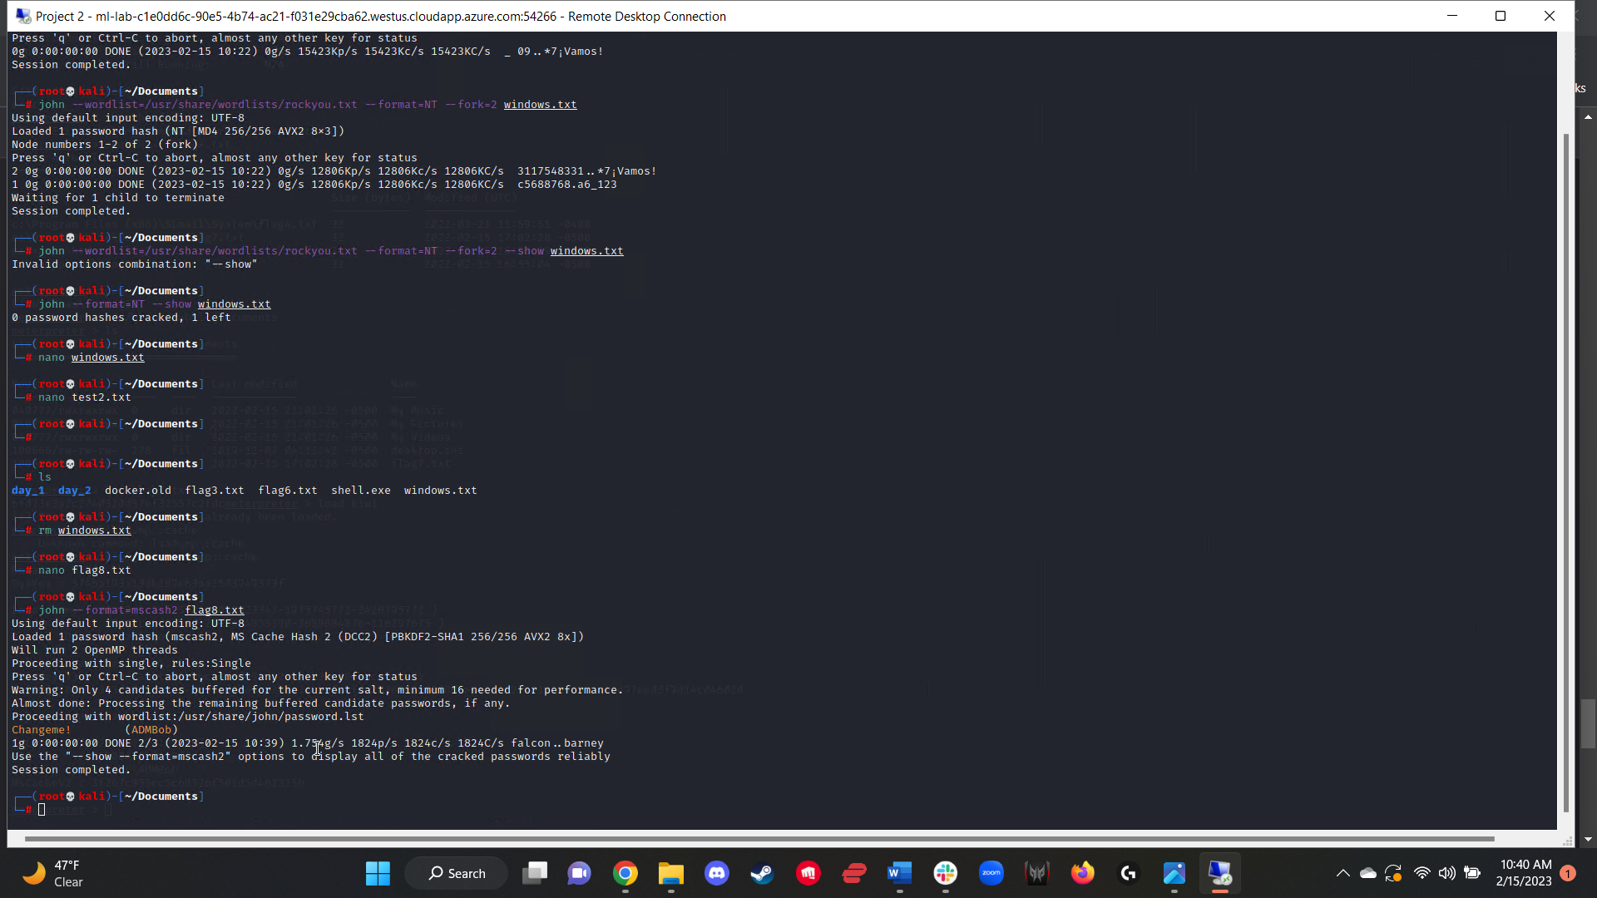

Figure 49:  
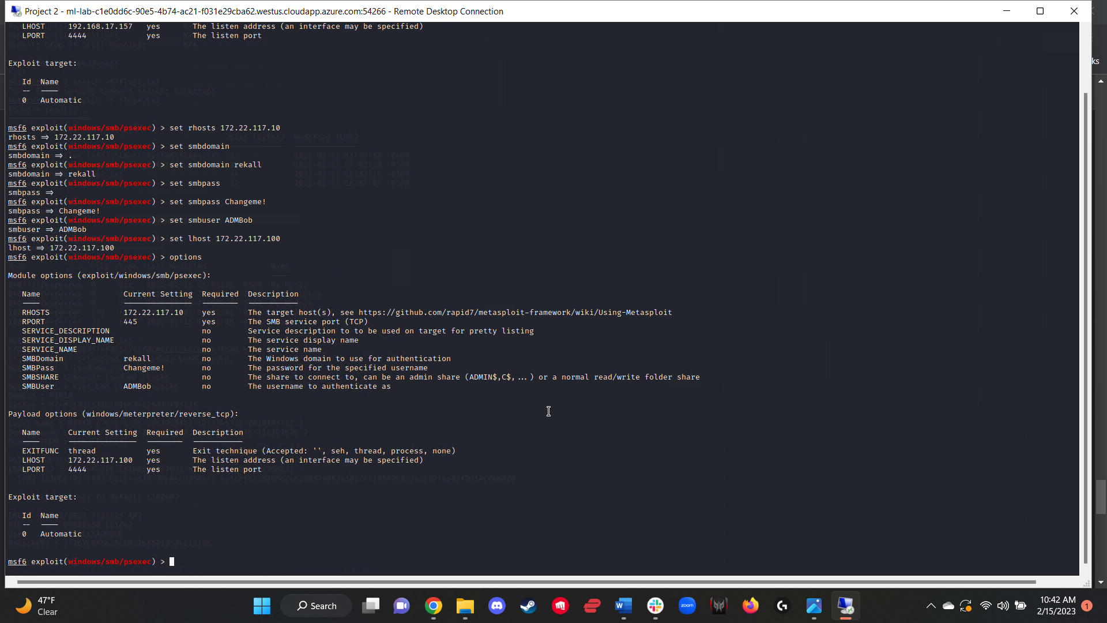

Figure 50:  
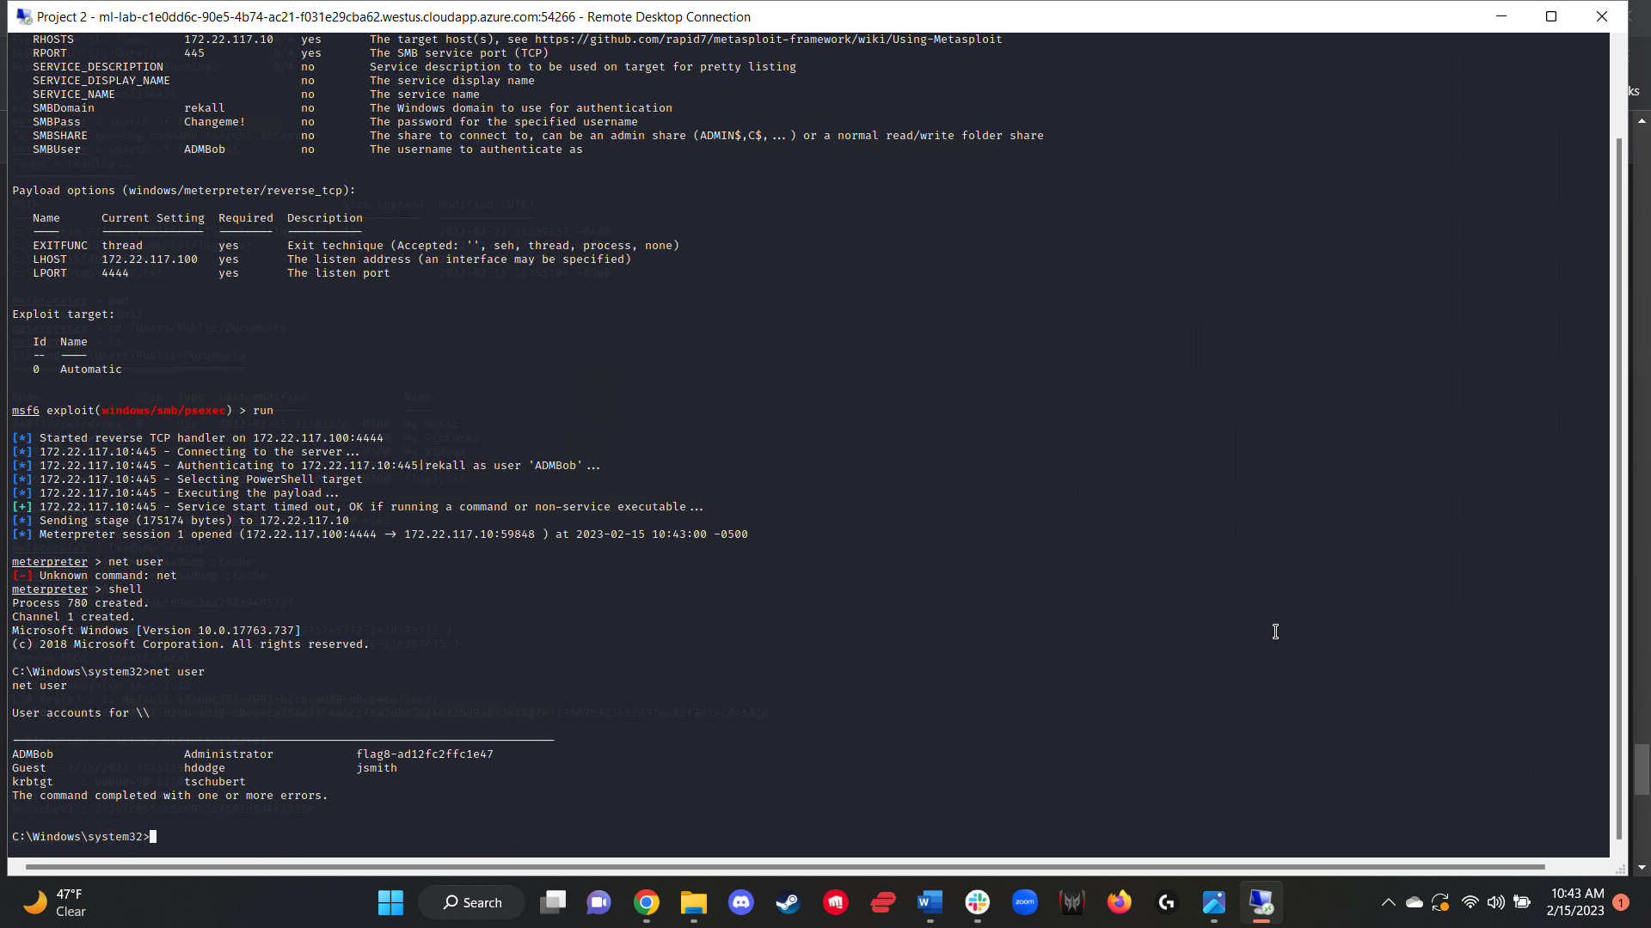

While still being within the 172.22.117.10 server, I continued to search through directories until I found the flag9.txt file in the C:\ directory (figure 51).

Figure 51:  
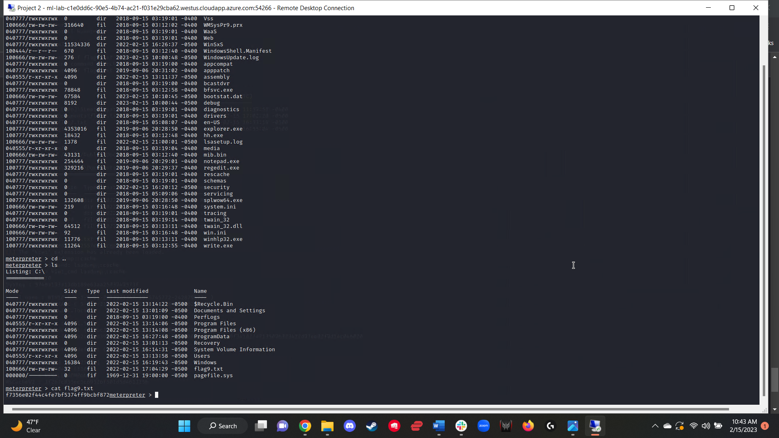

For the final flag, I needed to locate the password hash of the user “Administrator.” In order to do so, I once again loaded the *kiwi* extension and ran the *dcsync_ntlm administrator* command, which returned an output containing the NTLM hash of the user Administrator, which was also flag 10 (figure 52).

Figure 52:  
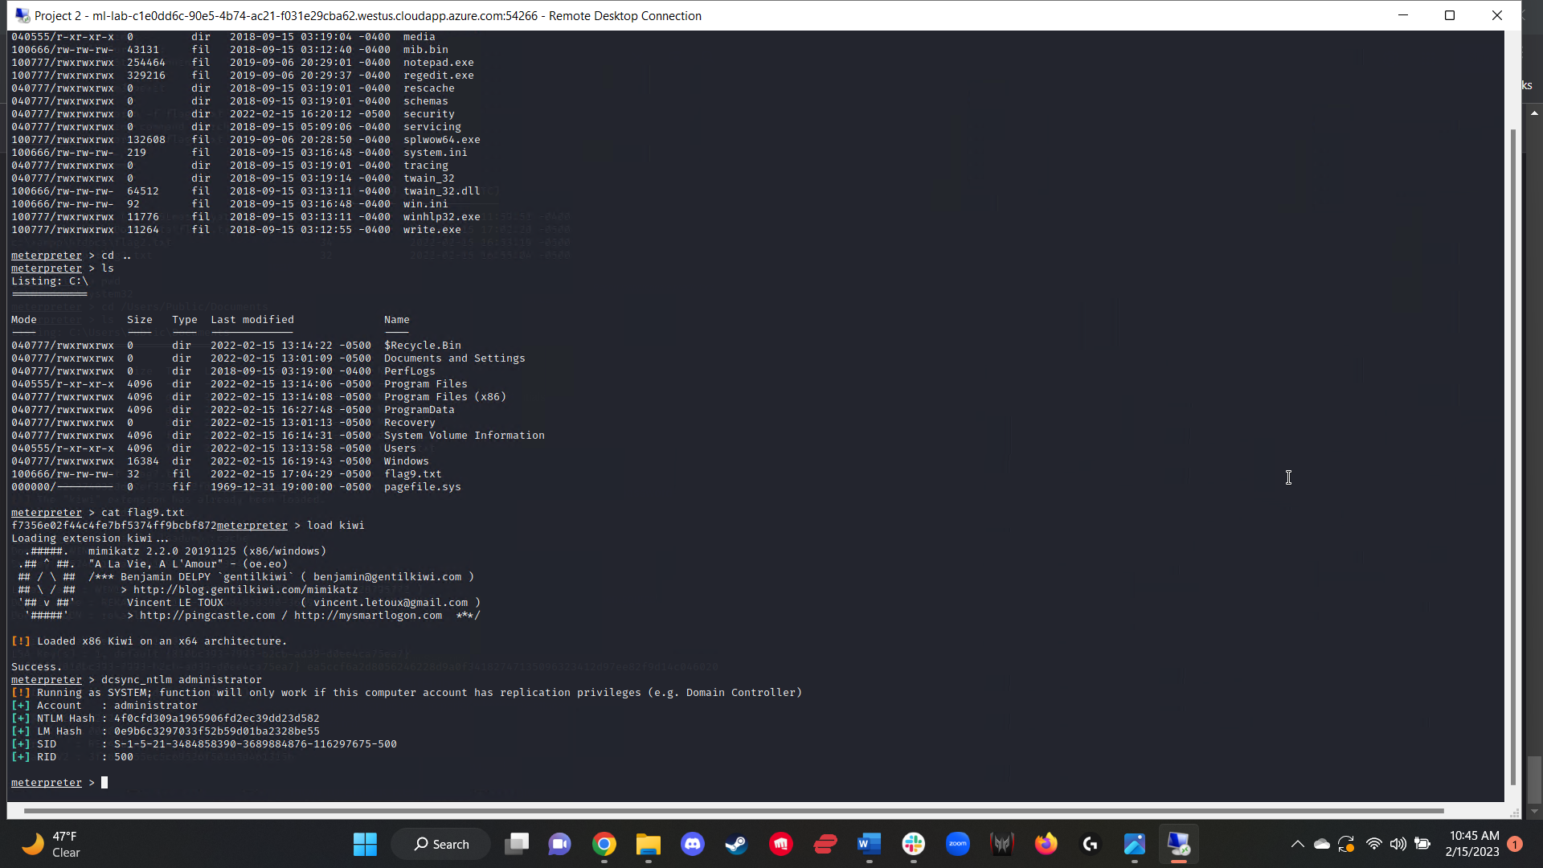

## 

## 

## 

## Summary Vulnerability Overview

| **Vulnerability** | **Severity** |
| --- | --- |
| Web CTF Flag 1 - XSS Reflected | **Critical** |
| Web CTF Flag 2 - XSS Reflected (Advanced) | **Critical** |
| Web CTF Flag 3 - XSS Stored | **Critical** |
| Web CTF Flag 4 - Sensitive Data Exposure | **Medium** |
| Web CTF Flag 5 - Local File Inclusion | **Critical** |
| Web CTF Flag 6 - Local File Inclusion (Advanced) | **Critical** |
| Web CTF Flag 7 - SQL Injection | **Critical** |
| Web CTF Flag 8 - Sensitive Data Exposure | **Critical** |
| Web CTF Flag 9 - Sensitive Data Exposure | **Critical** |
| Web CTF Flag 10 - Command Injection | **Critical** |
| Web CTF Flag 11 - Command Injection (Advanced) | **Critical** |
| Web CTF Flag 12 - Brute Force Attack | **Critical** |
| Web CTF Flag 13 - PHP Injection | **Critical** |
| Web CTF Flag 14 - Session Management | **Critical** |
| Web CTF Flag 15 - Directory Traversal | **Critical** |
| Linux CTF Flag 1 - Open Source Exposed Data | **Critical** |
| Linux CTF Flag 2 - No Vulnerability | **Informational** |
| Linux CTF Flag 3 - Open Source Exposed Data | **Informational** |
| Linux CTF Flag 4 - Network Mapping Scan | **Low** |
| Linux CTF Flag 5 - Network Mapping Scan | **Low** |
| Linux CTF Flag 6 - Nessus Scan | **Low** |
| Linux CTF Flag 7 - Apache Tomcat Remote Code Execution Vulnerability (CVE-2017-12617) | **Critical** |
| Linux CTF Flag 8 - Shellshock | **Critical** |
| Linux CTF Flag 9 - Shellshock | **Critical** |
| Linux CTF Flag 10 - Struts - CVE-2017-5638 | **Critical** |
| Linux CTF Flag 11 - Drupal - CVE-2019-6340 | **Critical** |
| Linux CTF Flag 12 - CVE-2019-14287 | **Critical** |
| Windows CTF Flag 1 - Open Source Exposed Data | **Critical** |
| Windows CTF Flag 2 - Password Cracking | **Critical** |
| Windows CTF Flag 3 - Open FTP Port 21 | **Critical** |
| Windows CTF Flag 4 - Seattle Lab Mail (SLmail) 5.5 - POP3 'PASS' Remote Buffer Overflow - CVE-2003-0264 | **Critical** |
| Windows CTF Flag 5 - Seattle Lab Mail (SLmail) 5.5 - POP3 'PASS' Remote Buffer Overflow - CVE-2003-0264 | **Critical** |
| Windows CTF Flag 6 - Seattle Lab Mail (SLmail) 5.5 - POP3 'PASS' Remote Buffer Overflow - CVE-2003-0264 | **Critical** |
| Windows CTF Flag 7 - Seattle Lab Mail (SLmail) 5.5 - POP3 'PASS' Remote Buffer Overflow - CVE-2003-0264 | **Critical** |
| Windows CTF Flag 8 - Microsoft Windows Authenticated User Code Execution - CVE-1999-0504 | **Critical** |
| Windows CTF Flag 9 - Microsoft Windows Authenticated User Code Execution - CVE-1999-0504 | **Critical** |
| Windows CTF Flag 10 - Microsoft Windows Authenticated User Code Execution - CVE-1999-0504 | **Critical** |

The following summary tables represent an overview of the assessment findings for this penetration test:

| **Scan Type** | **Total** |
| --- | --- |
| Hosts | 192.168.14.35  34.102.136.180  192.168.13.10  192.168.13.11  192.168.13.12  192.168.13.13  192.168.13.14  172.22.117.10  172.22.117.20 |
| Ports | 80, 8080, 22, 110, 445 |

| **Exploitation Risk** | **Total** |
| --- | --- |
| **Critical** | 31 |
| **High** | 0 |
| **Medium** | 1 |
| **Low** | 3 |
| **Informational** | 2 |

## Vulnerability Findings

| **Vulnerability 1** | **Findings** |
| --- | --- |
| **Title** | Flag 1 |
| **Type (Web app / Linux OS / WIndows OS)** | Web App |
| **Risk Rating** | Critical |
| **Description** | Reflected Cross Site Scripting |
| **Images** |  |
| **Affected Hosts** | 192.168.14.35 |
| **Remediation** | Validate all input data, only allow the allowlisted data, and ensure that all variable output in a page is encoded before being returned to the user. |

| **Vulnerability 2** | **Findings** |
| --- | --- |
| **Title** | Flag 2 |
| **Type (Web app / Linux OS / WIndows OS)** | Web App |
| **Risk Rating** | Critical |
| **Description** | Reflected Cross Site Scripting |
| **Images** |  |
| **Affected Hosts** | 192.168.14.35 |
| **Remediation** | Validate all input data, only allow the allowlisted data, and ensure that all variable output in a page is encoded before being returned to the user. |

| **Vulnerability 3** | **Findings** |
| --- | --- |
| **Title** | Flag 3 |
| **Type (Web app / Linux OS / WIndows OS)** | Web App |
| **Risk Rating** | Critical |
| **Description** | Stored Cross Site Scripting |
| **Images** |  |
| **Affected Hosts** | 192.168.14.35 |
| **Remediation** | Validate all input data, only allow the allowlisted data, and ensure that all variable output in a page is encoded before being returned to the user. |

| **Vulnerability 4** | **Findings** |
| --- | --- |
| **Title** | Sensitive Data Exposure |
| **Type (Web app / Linux OS / WIndows OS)** | Web App |
| **Risk Rating** | Medium |
| **Description** | Exposed data within the HTML page source. |
| **Images** |  |
| **Affected Hosts** | 192.168.14.35 |
| **Remediation** | Ensure no sensitive data is exposed in the .php file. |

| **Vulnerability 5** | **Findings** |
| --- | --- |
| **Title** | Flag 5 |
| **Type (Web app / Linux OS / WIndows OS)** | Web App |
| **Risk Rating** | Critical |
| **Description** | Local File Inclusion |
| **Images** |  |
| **Affected Hosts** | 192.168.14.35 |
| **Remediation** | Only allow jpeg files to be uploaded, preventing modified files from being uploaded. |

| **Vulnerability 6** | **Findings** |
| --- | --- |
| **Title** | Flag 6 |
| **Type (Web app / Linux OS / WIndows OS)** | Web App |
| **Risk Rating** | Critical |
| **Description** | Local File Inclusion |
| **Images** |  |
| **Affected Hosts** | 192.168.14.35 |
| **Remediation** | Only allow jpeg files to be uploaded, preventing modified files from being uploaded. |

| **Vulnerability 7** | **Findings** |
| --- | --- |
| **Title** | Flag 7 |
| **Type (Web app / Linux OS / WIndows OS)** | Web App |
| **Risk Rating** | Critical |
| **Description** | SQL Injection |
| **Images** |  |
| **Affected Hosts** | 192.168.14.35 |
| **Remediation** | Implement input validation, parameterized queries (prepared statements), and stored procedures. |

| **Vulnerability 8** | **Findings** |
| --- | --- |
| **Title** | Flag 8 |
| **Type (Web app / Linux OS / WIndows OS)** | Web App |
| **Risk Rating** | Critical |
| **Description** | Sensitive Data Exposure |
| **Images** |  |
| **Affected Hosts** | 192.168.14.35 |
| **Remediation** | Remove sensitive data from HTML source. Have the user change their password. |

| **Vulnerability 9** | **Findings** |
| --- | --- |
| **Title** | Flag 9 |
| **Type (Web app / Linux OS / WIndows OS)** | Web App |
| **Risk Rating** | Critical |
| **Description** | Sensitive Data Exposure |
| **Images** |  |
| **Affected Hosts** | 192.168.14.35 |
| **Remediation** | Remove ability to access the file via URL manipulation by preventing user supplied input from being passed into filesystem APIs. |

| **Vulnerability 10** | **Findings** |
| --- | --- |
| **Title** | Flag 10 |
| **Type (Web app / Linux OS / WIndows OS)** | Web App |
| **Risk Rating** | Critical |
| **Description** | Command Injection |
| **Images** |  |
| **Affected Hosts** | 192.168.14.35 |
| **Remediation** | Prevent OS commands from being called via the application-layer code. |

| **Vulnerability 11** | **Findings** |
| --- | --- |
| **Title** | Flag 11 |
| **Type (Web app / Linux OS / WIndows OS)** | Web App |
| **Risk Rating** | Critical |
| **Description** | Command Injection |
| **Images** |  |
| **Affected Hosts** | 192.168.14.35 |
| **Remediation** | Prevent OS commands from being called via the application-layer code. |

| **Vulnerability 12** | **Findings** |
| --- | --- |
| **Title** | Flag 12 |
| **Type (Web app / Linux OS / WIndows OS)** | Web App |
| **Risk Rating** | Critical |
| **Description** | Brute Force Attack |
| **Images** |  |
| **Affected Hosts** | 192.168.14.35 |
| **Remediation** | Have the user change their password immediately. Remove access to /etc/passwd via remediation recommended above to prevent URL file manipulation. |

| **Vulnerability 13** | **Findings** |
| --- | --- |
| **Title** | Flag 13 |
| **Type (Web app / Linux OS / WIndows OS)** | Web App |
| **Risk Rating** | Critical |
| **Description** | PHP Injection |
| **Images** |  |
| **Affected Hosts** | 192.168.14.35 |
| **Remediation** | Require input validation, avoid using core PHP functionality in the source code, such as shell_exec(), employ a PHP security linter. |

| **Vulnerability 14** | **Findings** |
| --- | --- |
| **Title** | Flag 14 |
| **Type (Web app / Linux OS / WIndows OS)** | Web App |
| **Risk Rating** | Critical |
| **Description** | Session Management |
| **Images** |  |
| **Affected Hosts** | 192.168.14.35 |
| **Remediation** | Exclusively use HTTPS to transfer session ID tokens, do not expose session ID in URL, ensure that there are session timeouts, and that sessions are terminated upon user logout. |

| **Vulnerability 15** | **Findings** |
| --- | --- |
| **Title** | Flag 15 |
| **Type (Web app / Linux OS / WIndows OS)** | Web App |
| **Risk Rating** | Critical |
| **Description** | Directory Traversal |
| **Images** |  |
| **Affected Hosts** | 192.168.14.35 |
| **Remediation** | Implement URL mapping to separate the URL from the underlying files. |

| **Vulnerability 1** | **Findings** |
| --- | --- |
| **Title** | Flag 1 |
| **Type (Web app / Linux OS / WIndows OS)** | Linux OS |
| **Risk Rating** | Critical |
| **Description** | Open Source Exposed Data |
| **Images** |  |
| **Affected Hosts** | 34.102.136.180 |
| **Remediation** | Remove user info from WHOIS database and utilize a WHOIS privacy service. |

| **Vulnerability 2** | **Findings** |
| --- | --- |
| **Title** | Flag 2 |
| **Type (Web app / Linux OS / WIndows OS)** | Linux OS |
| **Risk Rating** | Informational |
| **Description** | Open Source Exposed Data |
| **Images** |  |
| **Affected Hosts** | 34.102.136.180 |
| **Remediation** | None required. |

| **Vulnerability 3** | **Findings** |
| --- | --- |
| **Title** | Flag 3 |
| **Type (Web app / Linux OS / WIndows OS)** | Linux OS |
| **Risk Rating** | Informational |
| **Description** | Open Source Exposed Data |
| **Images** |  |
| **Affected Hosts** | 34.102.136.180 |
| **Remediation** | Keys are not private, no need to hide certificate records. No remediation required. |

| **Vulnerability 4** | **Findings** |
| --- | --- |
| **Title** | Flag 4 |
| **Type (Web app / Linux OS / WIndows OS)** | Linux OS |
| **Risk Rating** | Low |
| **Description** | Network Mapping Scan |
| **Images** |  |
| **Affected Hosts** | 192.168.13.1/28 |
| **Remediation** | Can put firewalls into place so as to prevent outside traffic from being able to read/access open ports. |

| **Vulnerability 5** | **Findings** |
| --- | --- |
| **Title** | Flag 5 |
| **Type (Web app / Linux OS / WIndows OS)** | Linux OS |
| **Risk Rating** | Low |
| **Description** | Network Mapping Scan |
| **Images** |  |
| **Affected Hosts** | 192.168.13.13 |
| **Remediation** | Can put firewalls into place so as to prevent outside traffic from being able to read/access open ports. |

| **Vulnerability 6** | **Findings** |
| --- | --- |
| **Title** | Flag 6 |
| **Type (Web app / Linux OS / WIndows OS)** | Linux OS |
| **Risk Rating** | Low |
| **Description** | Nessus Scan |
| **Images** |  |
| **Affected Hosts** | 192.168.13.12 |
| **Remediation** | Can put firewalls into place so as to prevent outside traffic from being able to read/access open ports. |

| **Vulnerability 7** | **Findings** |
| --- | --- |
| **Title** | Flag 7 |
| **Type (Web app / Linux OS / WIndows OS)** | Linux OS |
| **Risk Rating** | Critical |
| **Description** | Apache Tomcat Remote Code Execution Vulnerability (CVE-2017-12617) |
| **Images** |  |
| **Affected Hosts** | 192.168.13.10 |
| **Remediation** | Update Apache Tomcat to the most recent version. Can also close port 8080 to outside sources. |

| **Vulnerability 8** | **Findings** |
| --- | --- |
| **Title** | Flag 8 |
| **Type (Web app / Linux OS / WIndows OS)** | Linux OS |
| **Risk Rating** | Critical |
| **Description** | Shellshock Exploitation |
| **Images** |  |
| **Affected Hosts** | 192.168.13.11 |
| **Remediation** | Update Bash that comes with the default package manager of the system to the most recent version. Can also close port 80 to outside sources. |

| **Vulnerability 9** | **Findings** |
| --- | --- |
| **Title** | Flag 9 |
| **Type (Web app / Linux OS / WIndows OS)** | Linux OS |
| **Risk Rating** | Critical |
| **Description** | Shellshock Exploitation |
| **Images** |  |
| **Affected Hosts** | 192.168.13.11 |
| **Remediation** | Update Bash that comes with the default package manager of the system to the most recent version. Can also close port 80 to outside sources. |

| **Vulnerability 10** | **Findings** |
| --- | --- |
| **Title** | Flag 10 |
| **Type (Web app / Linux OS / WIndows OS)** | Linux OS |
| **Risk Rating** | Critical |
| **Description** | Struts - CVE-2017-5638 |
| **Images** |  |
| **Affected Hosts** | 192.168.13.12 |
| **Remediation** | Update Apache Struts to the most recent version. Can also close port 8080 to outside sources. |

| **Vulnerability 11** | **Findings** |
| --- | --- |
| **Title** | Flag 11 |
| **Type (Web app / Linux OS / WIndows OS)** | Linux OS |
| **Risk Rating** | Critical |
| **Description** | Drupal - CVE-2019-6340 |
| **Images** |  |
| **Affected Hosts** | 192.168.13.13 |
| **Remediation** | Update Drupal to the most recent version. Can also close port 80 to outside sources. |

| **Vulnerability 12** | **Findings** |
| --- | --- |
| **Title** | Flag 12 |
| **Type (Web app / Linux OS / WIndows OS)** | Linux OS |
| **Risk Rating** | Critical |
| **Description** | CVE-2019-14287 |
| **Images** |  |
| **Affected Hosts** | 192.168.13.14 |
| **Remediation** | Examine each sudoers entry that includes the `!` character in the runas specification in order to ensure that the root user is not among the excluded users. All exclusions can be found in the /etc/sudoers file or files under /etc/sudoers.d  Can also close port 22 to outside sources to prevent external SSH into system. |

| **Vulnerability 1** | **Findings** |
| --- | --- |
| **Title** | Flag 1 |
| **Type (Web app / Linux OS / WIndows OS)** | Windows OS |
| **Risk Rating** | Critical |
| **Description** | Open Source Exposed Data |
| **Images** |  |
| **Affected Hosts** | 172.22.117.20 |
| **Remediation** | Remove user credentials and password hash off of the publicly available web page. Have user change their password immediately. |

| **Vulnerability 2** | **Findings** |
| --- | --- |
| **Title** | Flag 2 |
| **Type (Web app / Linux OS / WIndows OS)** | Windows OS |
| **Risk Rating** | Critical |
| **Description** | Password Cracking and Network Mapping Scan |
| **Images** |  |
| **Affected Hosts** | 172.22.117.20 |
| **Remediation** | Ensure the user changes their password. Potentially close HTTP port to outside sources if the domain is not meant to be public facing. |

| **Vulnerability 3** | **Findings** |
| --- | --- |
| **Title** | Flag 3 |
| **Type (Web app / Linux OS / WIndows OS)** | Windows OS |
| **Risk Rating** | Critical |
| **Description** | Open Port 21 - FTP Permitted |
| **Images** |  |
| **Affected Hosts** | 172.22.117.20 |
| **Remediation** | Close port 21 to outside sources. |

| **Vulnerability 4** | **Findings** |
| --- | --- |
| **Title** | Flag 4 |
| **Type (Web app / Linux OS / WIndows OS)** | Windows OS |
| **Risk Rating** | Critical |
| **Description** | Seattle Lab Mail (SLmail) 5.5 - POP3 'PASS' Remote Buffer Overflow - CVE-2003-0264 |
| **Images** |  |
| **Affected Hosts** | 172.22.117.20 |
| **Remediation** | Update SLMAIL to the most recent available version. Also, consider closing port 110 to outside sources. |

| **Vulnerability 5** | **Findings** |
| --- | --- |
| **Title** | Flag 5 |
| **Type (Web app / Linux OS / WIndows OS)** | Windows OS |
| **Risk Rating** | Critical |
| **Description** | Seattle Lab Mail (SLmail) 5.5 - POP3 'PASS' Remote Buffer Overflow - CVE-2003-0264 |
| **Images** |  |
| **Affected Hosts** | 172.22.117.20 |
| **Remediation** | Update SLMAIL to the most recent available version. Also, consider closing port 110 to outside sources. |

| **Vulnerability 6** | **Findings** |
| --- | --- |
| **Title** | Flag 6 |
| **Type (Web app / Linux OS / WIndows OS)** | Windows OS |
| **Risk Rating** | Critical |
| **Description** | Seattle Lab Mail (SLmail) 5.5 - POP3 'PASS' Remote Buffer Overflow - CVE-2003-0264 |
| **Images** |  |
| **Affected Hosts** | 172.22.117.20 |
| **Remediation** | Update SLMAIL to the most recent available version. Also, consider closing port 110 to outside sources. |

| **Vulnerability 7** | **Findings** |
| --- | --- |
| **Title** | Flag 7 |
| **Type (Web app / Linux OS / WIndows OS)** | Windows OS |
| **Risk Rating** | Critical |
| **Description** | Seattle Lab Mail (SLmail) 5.5 - POP3 'PASS' Remote Buffer Overflow - CVE-2003-0264 |
| **Images** |  |
| **Affected Hosts** | 172.22.117.20 |
| **Remediation** | Update SLMAIL to the most recent available version. Also, consider closing port 110 to outside sources. |

| **Vulnerability 8** | **Findings** |
| --- | --- |
| **Title** | Flag 8 |
| **Type (Web app / Linux OS / WIndows OS)** | Windows OS |
| **Risk Rating** | Critical |
| **Description** | Microsoft Windows Authenticated User Code Execution - CVE-1999-0504 - PsExec |
| **Images** |  |
| **Affected Hosts** | 172.22.117.10 |
| **Remediation** | Configure Windows Registry to require UAC approval for any PsExec operations. Can also close 445 to outside sources. |

| **Vulnerability 9** | **Findings** |
| --- | --- |
| **Title** | Flag 9 |
| **Type (Web app / Linux OS / WIndows OS)** | Windows OS |
| **Risk Rating** | Critical |
| **Description** | Microsoft Windows Authenticated User Code Execution - CVE-1999-0504 - PsExec |
| **Images** |  |
| **Affected Hosts** | 172.22.117.0/24 |
| **Remediation** | Configure Windows Registry to require UAC approval for any PsExec operations. Can also close 445 to outside sources. |

| **Vulnerability 10** | **Findings** |
| --- | --- |
| **Title** | Flag 10 |
| **Type (Web app / Linux OS / WIndows OS)** | Windows OS |
| **Risk Rating** | Critical |
| **Description** | Microsoft Windows Authenticated User Code Execution - CVE-1999-0504 - PsExec |
| **Images** |  |
| **Affected Hosts** | 172.22.117.0/24 |
| **Remediation** | Configure Windows Registry to require UAC approval for any PsExec operations. Can also close 445 to outside sources. |